<https://university.atlassian.com/student/award/QHEj59DXL3ZwJPf8C4EC9eiN>

Confluence is your go-to tool for creating content, finding resources, and collaborating with your teammates.

**What is Confluence?**

**Confluence is a tool to create, store, and share information.**

**Think of Confluence as the "central hub" for all your team's work —**a place where you can easily create and find the information you need to do your job.

**✅ Create information:**Create pages. Build how-to materials. Brainstorm ideas. Capture thoughts. Plan new projects.

**✅ Store information:**Store resources. Organize pages. Easily find the information you need.

**✅ Share information:**Share projects. Give and receive feedback. Collaborate across teams.

**All types of teams use Confluence,**from marketing to human resources.Regardless of size or function, Confluence can help every team be more transparent, efficient, and collaborative.

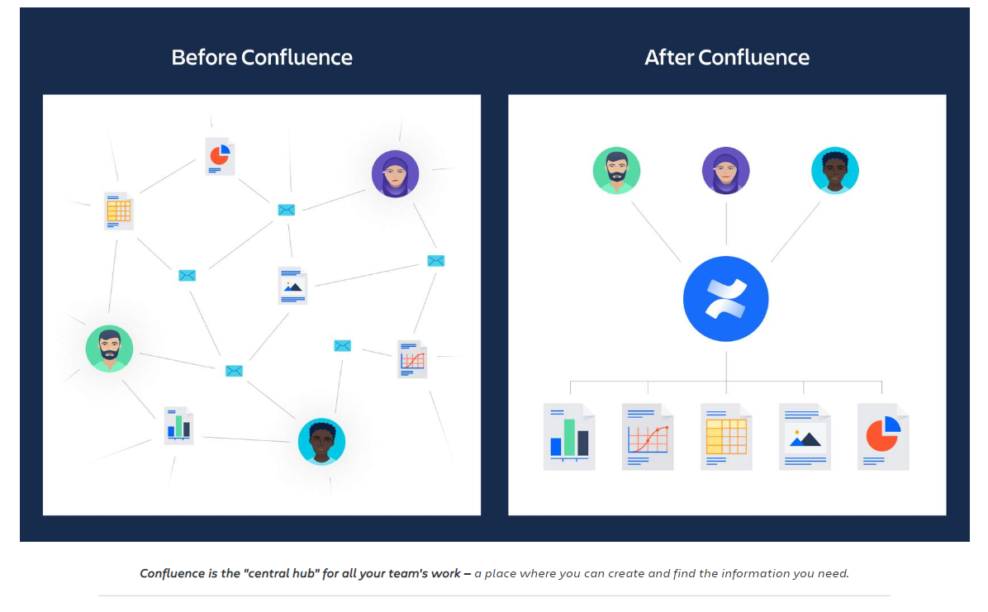

**Why do teams use Confluence?**

**Confluence is a flexible tool. It can be used to solve many different types of problems.**  to **manage knowledge**, to **collaborate on projects**, and to **engage with employees**.



For example, if your team uses Confluence to manage knowledge, you'll know to focus on finding and organizing content. If your team uses Confluence to collaborate on projects, you'll know to focus on sharing files and commenting on content.

**Along with being a better teammate, using Confluence can helpyoube a better leader and employee.**How? As you start using Confluence, you'll see that it helps you:

✅ **Communicate and socialize your ideas**with well-structured content

✅ **Find essential resources** you need to do your job

✅ **Brainstorm and document** your most important ideas

✅**Give and receive feedback** with teammates in real-time

✅ **Stay in the loop** on your team's work

**Use Confluence every day to communicate and collaborate with your team.**

**Confluence is a collaboration tool your team has chosen.** It's here to help your entire team be better at their jobs. Like any tool, you can learn Confluence and use it to your advantage to improve your performance and ultimately boost your career.

**What's your role in Confluence?**

**As a user, your role will be to view, edit, and create pages.**

**Pages** are documents you can create in Confluence. They can be filled with text, tables, and multimedia — similar to other digital documents you may have used. The difference is that every Confluence page lives online and can be edited in real-time with your teammates.

You can create pages for nearly any purpose: marketing campaigns, HR policies, product requirements, how-to support materials, even personal brainstorming notes. There are no limitations to the types of pages you can create.

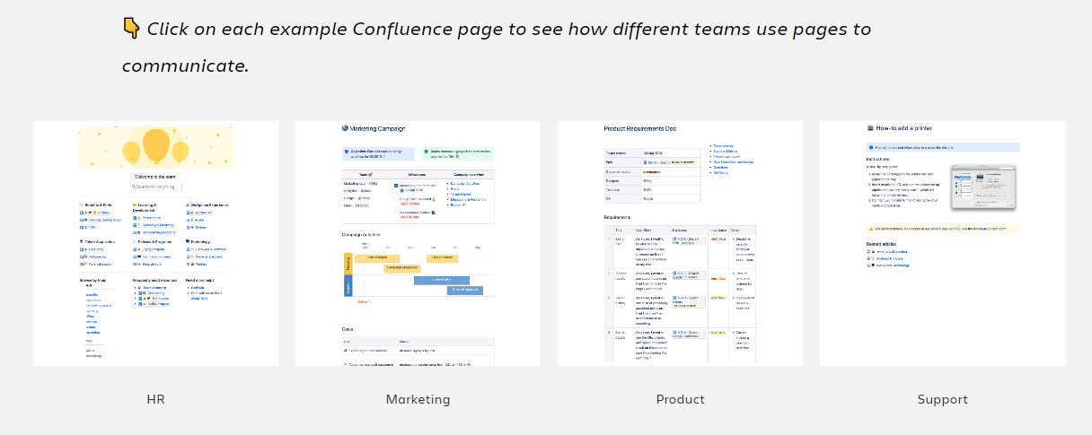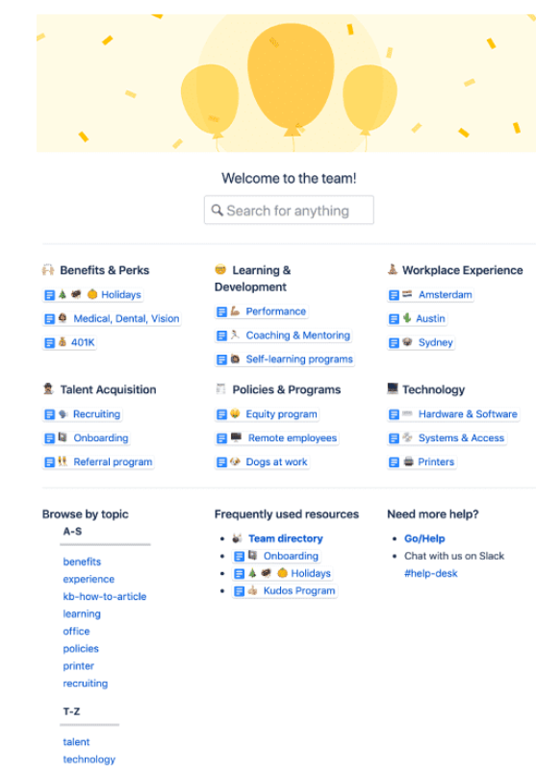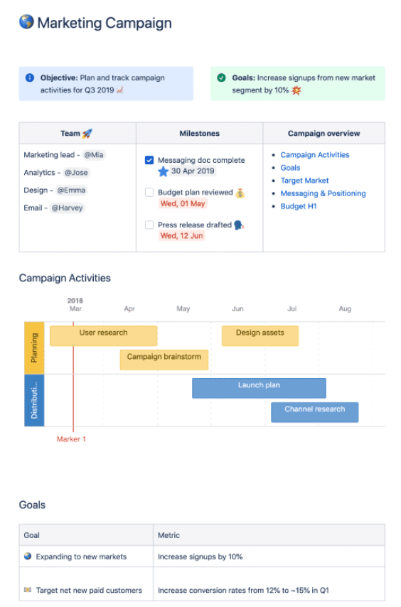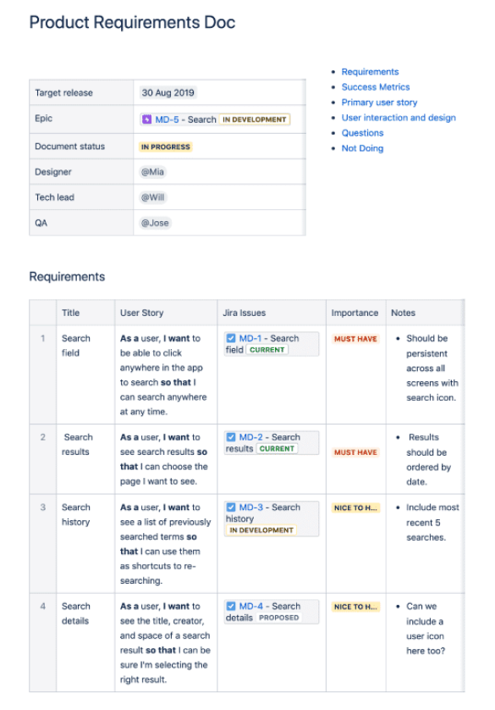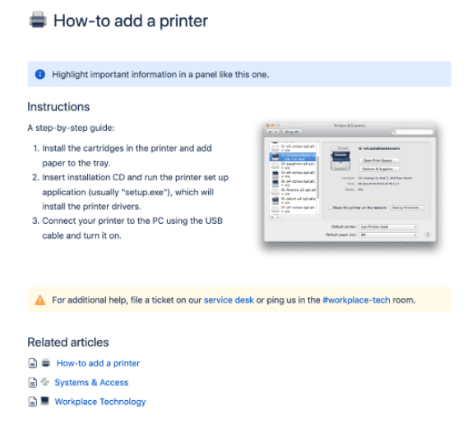👇 Click through the tabs for an overview of how you'll use pages.

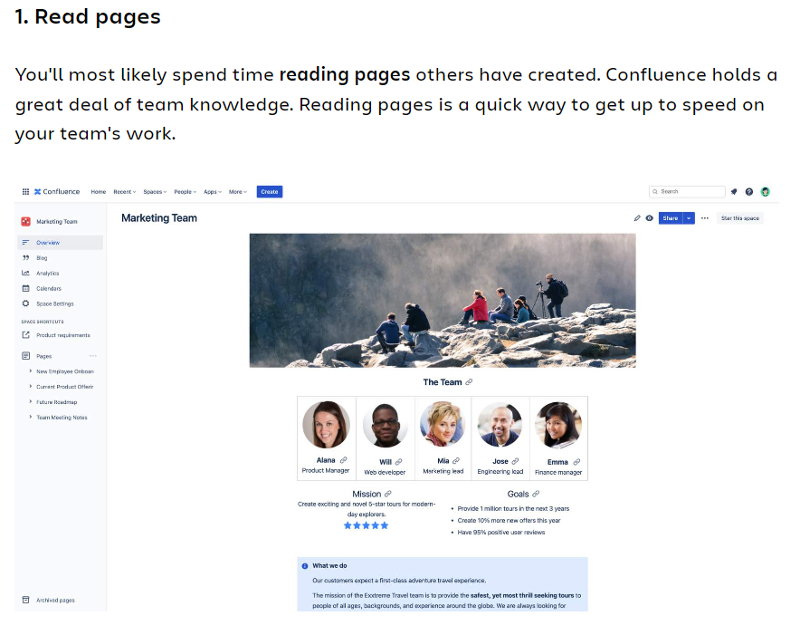

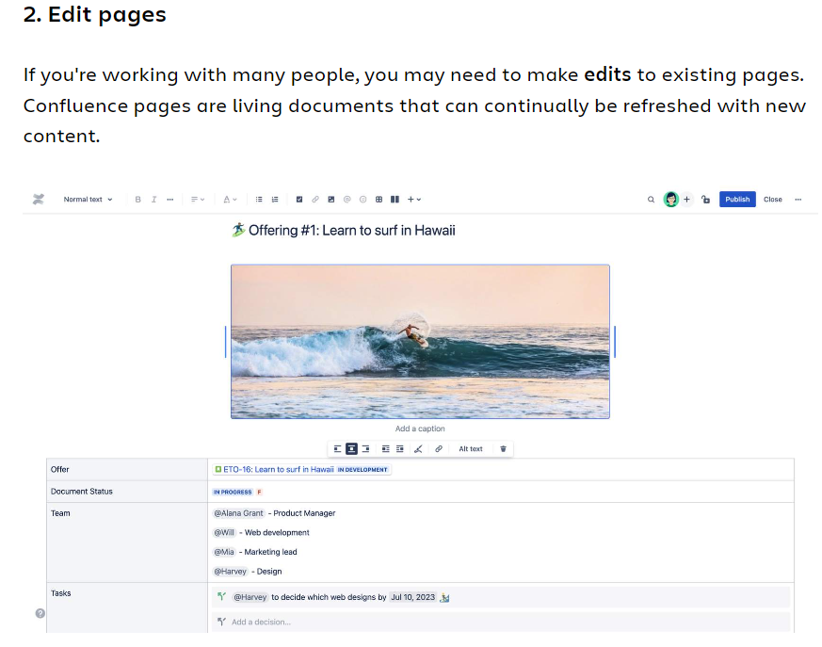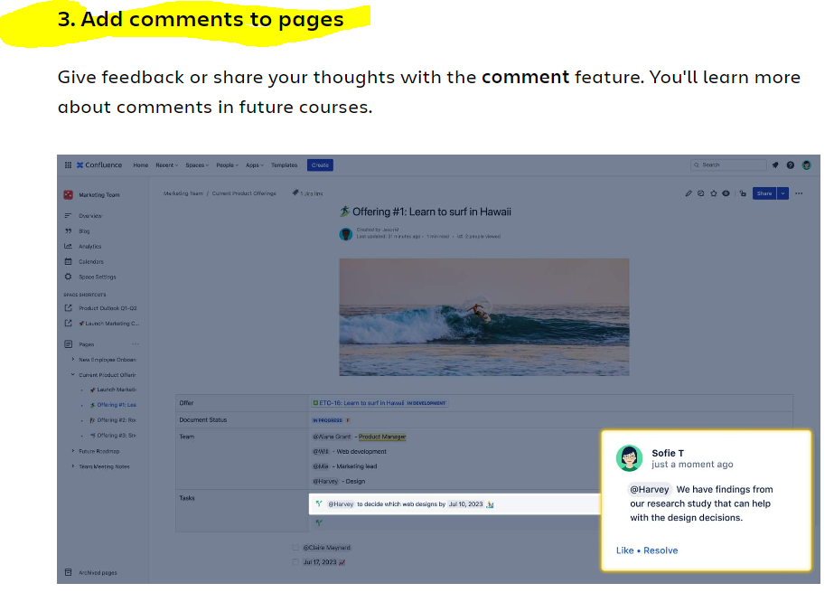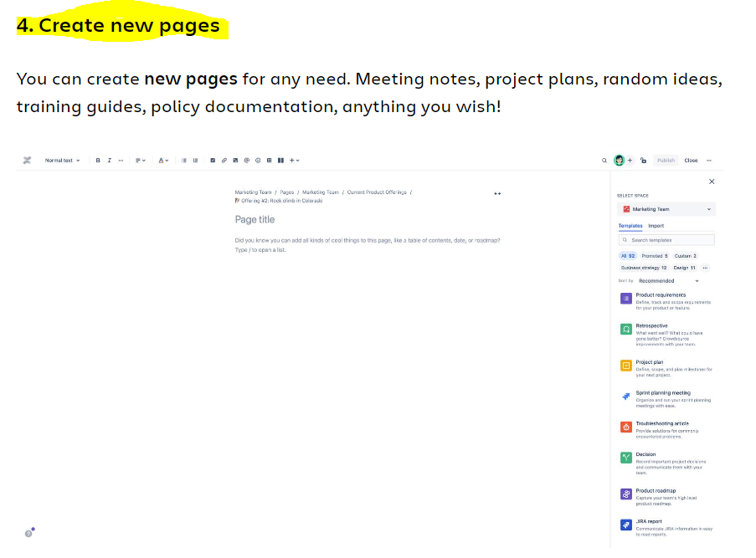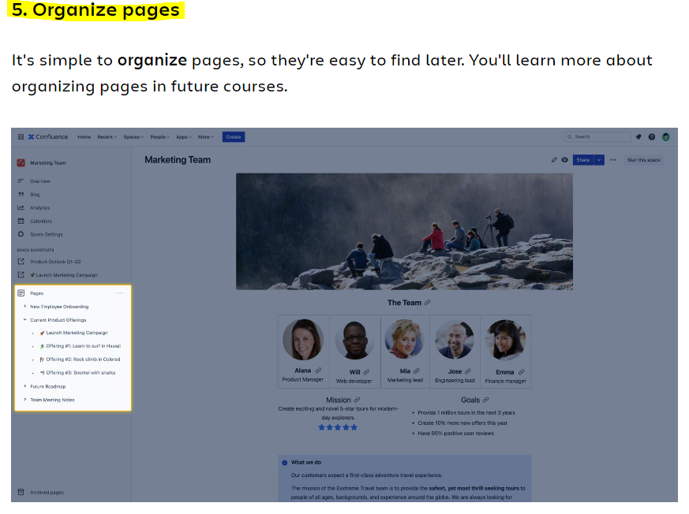

**Pagesare contained within spaces**

A **space** is a collection of related pages. Your team may have hundreds of **pages**, all contained within a single **space**. Spaces help organize pages into meaningful categories.

**As a user, you probably won't need to create spaces.** Your Confluence administrator or team leader may have one or more spaces set up for you. You'll learn more about spaces in the next lesson.

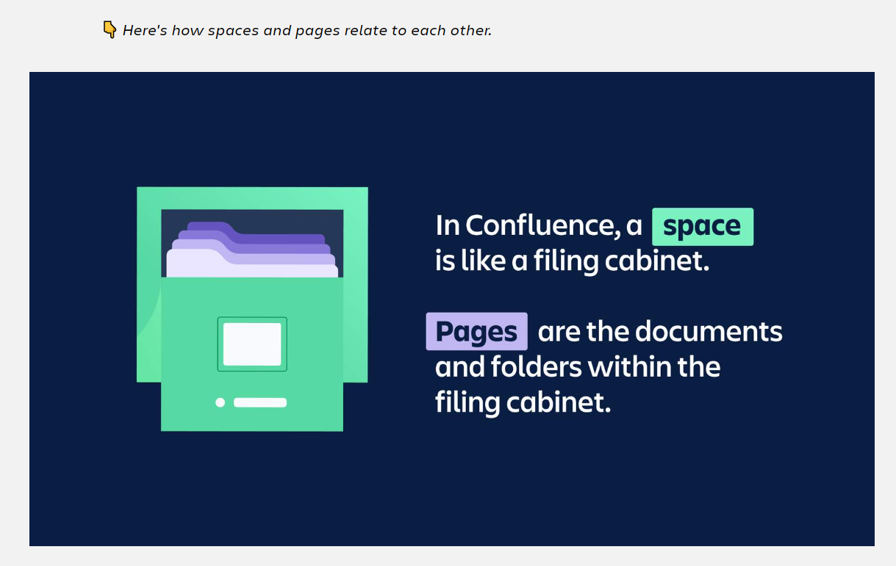

**Do you have Confluence open on your screen?**

If not, pull it up now so you can get familiar with the interface. You already learned about**pages** and **spaces**. Let's see what they look like on your screen.

**Start on the homepage.**Select *'Home'* in the **main navigation bar** at the top of your screen, to get to the homepage. Your homepage may look slightly different than the screen below.

👇 *Click the number icons to learn about the homepage.*

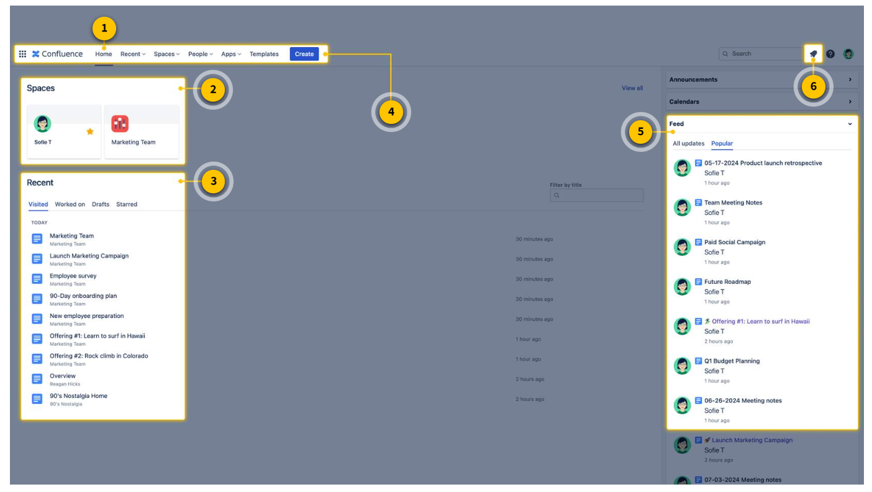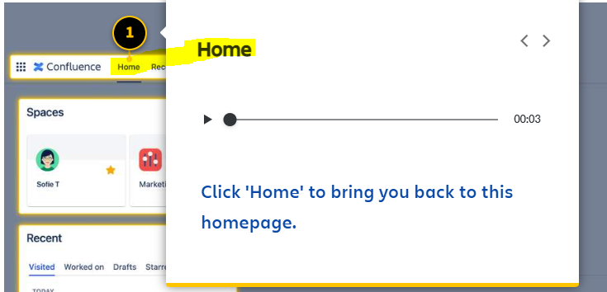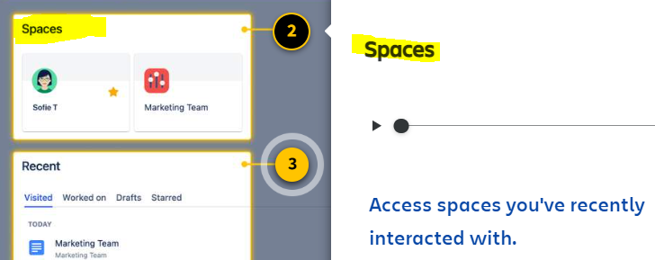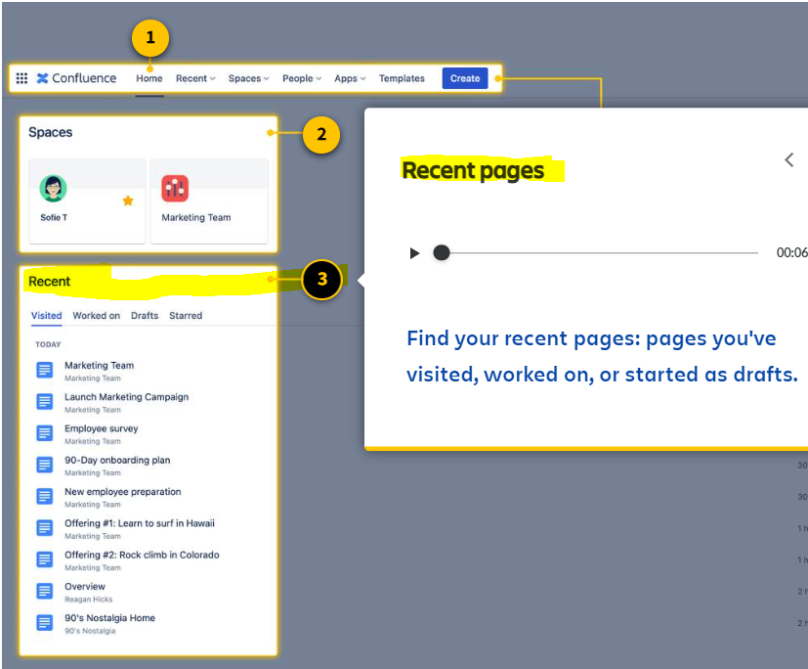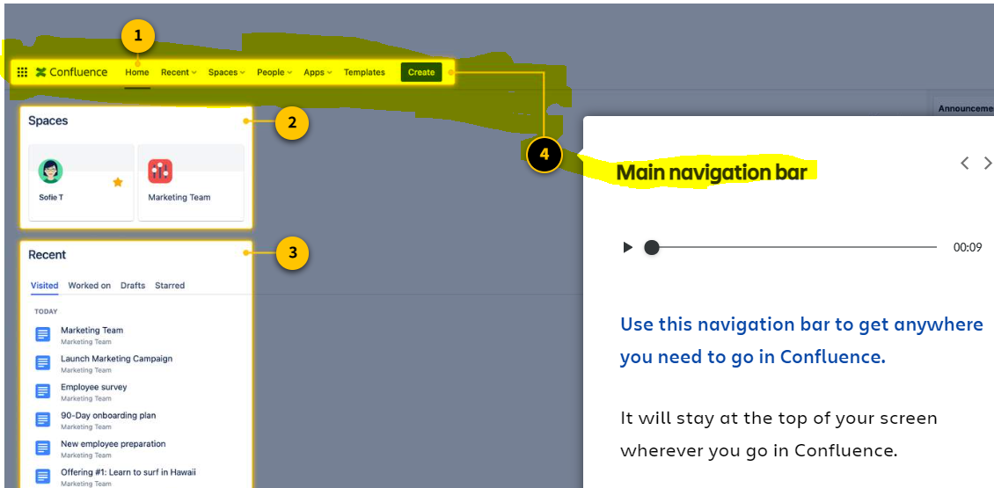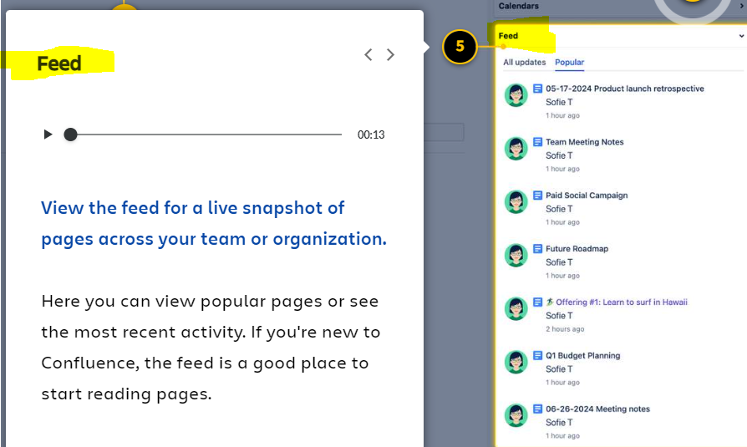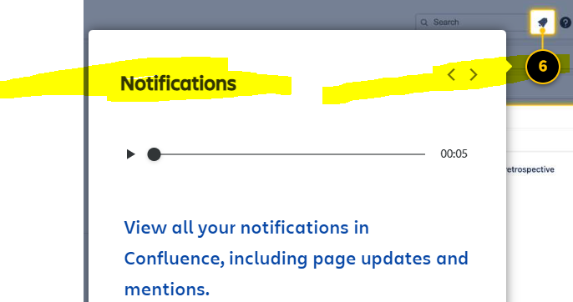

**How to change your space**

You may have access to more than one space, depending on your permissions.

**To change your space, select the *'Spaces'* dropdown in the main navigation bar.** Select a space from the list. You also have the option to click *'View all spaces'* to see all spaces available to you.

👇 *Select the 'Spaces' dropdown to change to a different space.*

**What's inside a space?**

**Get to know the space overview and space sidebar.**

When you select a space from the dropdown, it brings you to the **space overview**. This is the first page you see when you arrive at a space. Space overviews can be fully customized to fit the needs of your team, so yours may look different than the examples.

Now that you've entered a space, you'll see a collapsible menu on the left of your screen. This is the **space sidebar**, a menu to guide you around the space. From here you can access the blog, analytics, calendar, and most importantly, any page within the space.

👇 *Here is a space overview and the collapsible space sidebar.*

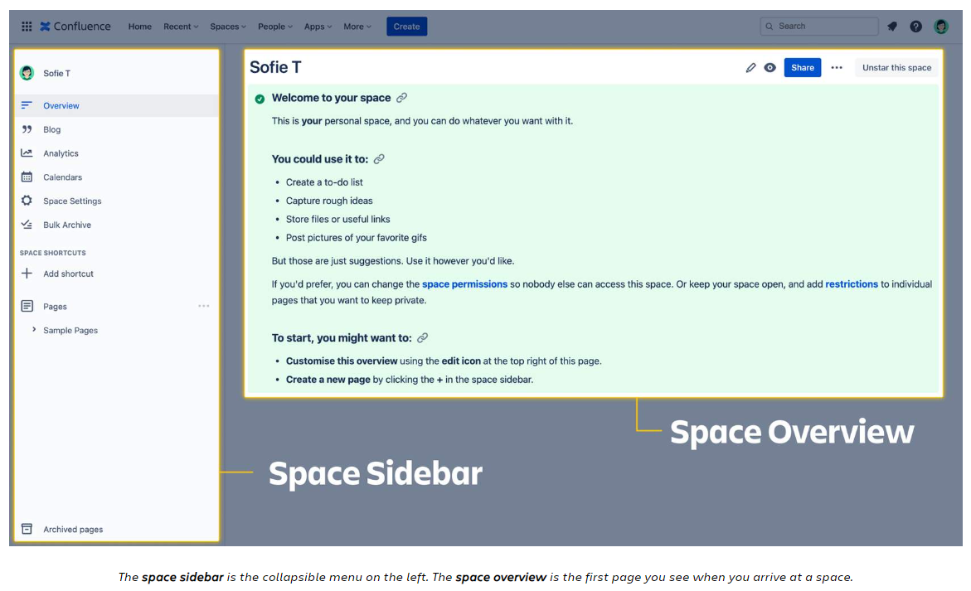**How are your spaces set up?**

Spaces are purposefully flexible. Your organization can create spaces for anything. Here are the most common ways organizations set up spaces:

**🟢 Team space (*most popular):**A space organized by team, like *'Marketing Team.'*This helps a team contain pages related to their team only

**🟢 Project space (*most popular):** A space organized around a particular project, like *'Q1 Engagement Campaign.*' This helps contain pages related to a specific project.

🟢**Documentation space:** A space to create and organize technical documentation for your products or services.

🟢**Knowledge base space:**A space to store answers to common questions, such as policies and IT solutions.

🟢**Personal space:**A space just for you! You can use a personal space to write down ideas, organize notes, keep track of goals, or document anything else you'd like.

Most teams set up spaces in one of two ways: by **team** or by **project**. How are *your*spaces set up? Take a look at the names of your spaces. This will help you understand how spaces are set up and how your team is structuring the work.

👇 *Here is how you can identify the name of your space.*

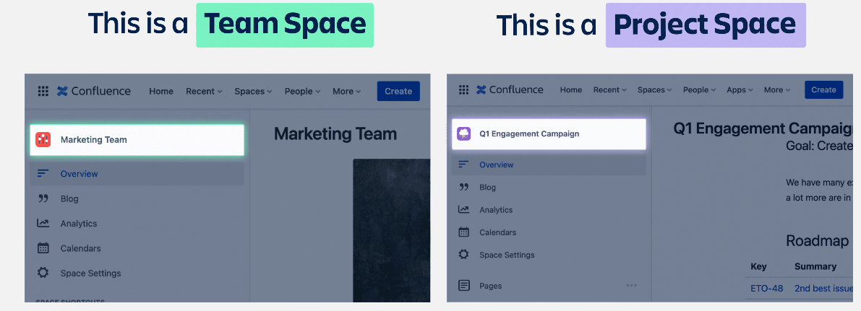**Ready to explore your spaces?**

**Open your Confluence and follow the steps below.**

* **1. Select 'Spaces':** In the main navigation bar, click the **'Spaces'**dropdown.
* **2. Find a space:**If you have access to more than one space, select a different space.
* **3. Explore the space overview:**View the space overview and consider how this space is named.

**View and find existing pages**

**What's on a page?**

**Pages are filled with rich, dynamic content.**They can include text, tables, information callouts, images, videos, graphs, and other elements. Every page author has the creative freedom to build a page to their preference.

Navigating around in pages is easy. They're just like websites. Scroll up and down a page to view its content.

👇 *This is an example Confluence page. They are easy for anyone to navigate.*

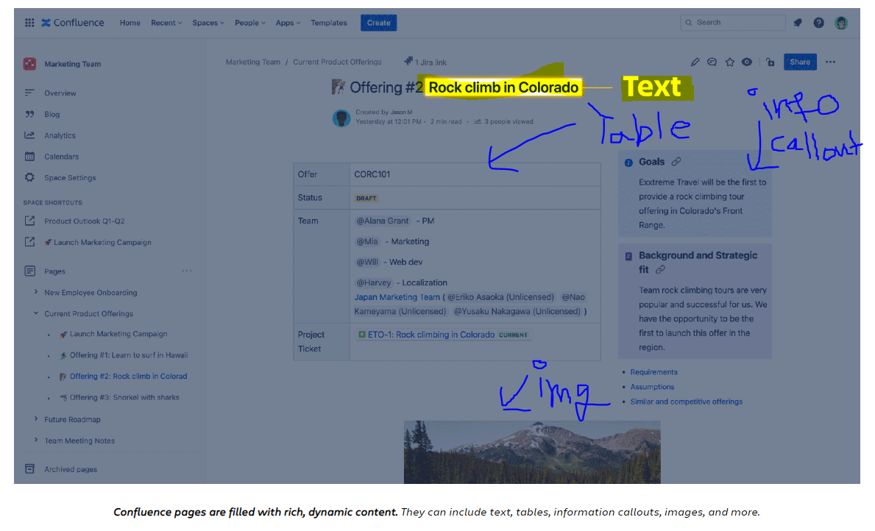**Get to know the page options**

Near the top right of every page, there is a set of page options. This is how you edit, comment on, share, and update the permissions of pages. You'll use these page options frequently.

**Note: your page options may look different than the example below. Based on the permissions of the page and space, you may not have access to specific options.**

👇 *Click the numbers to learn about each page option.*

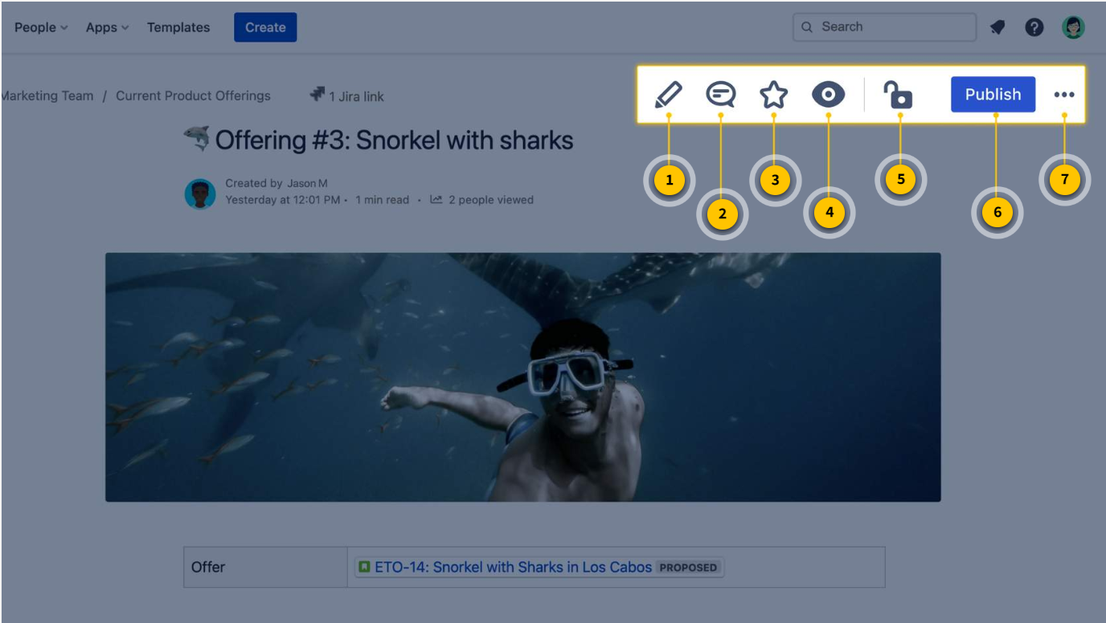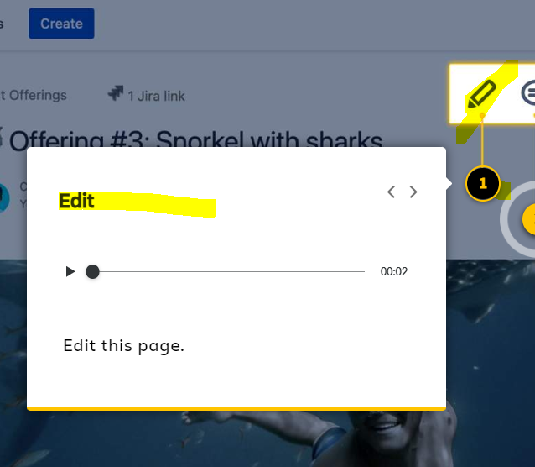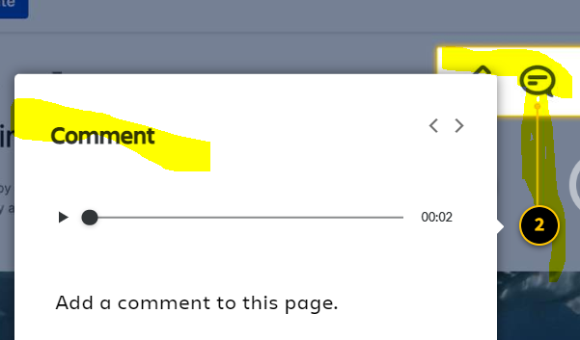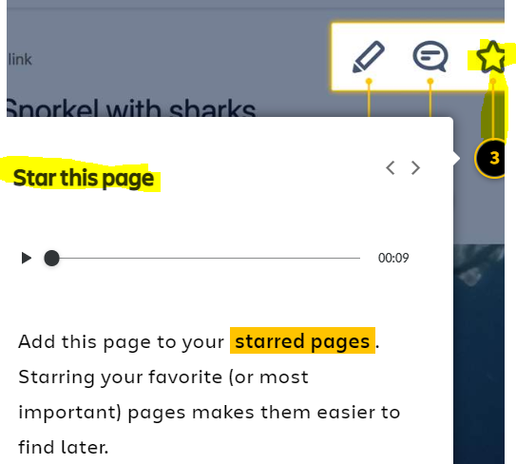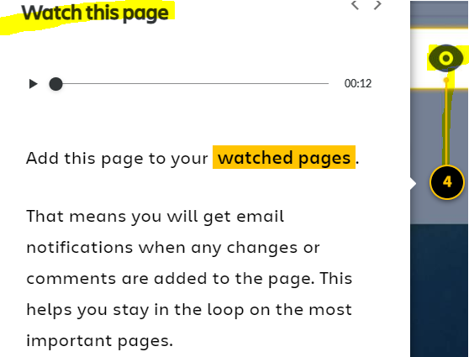

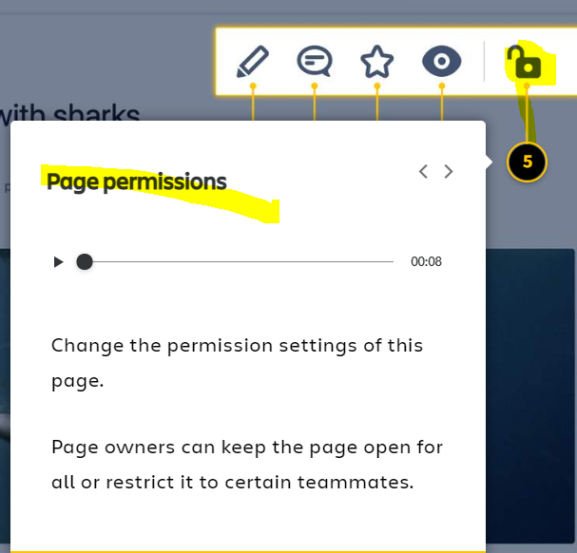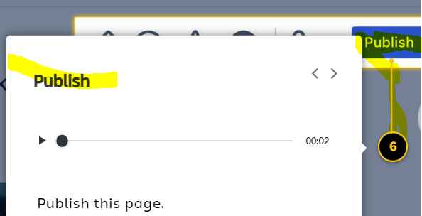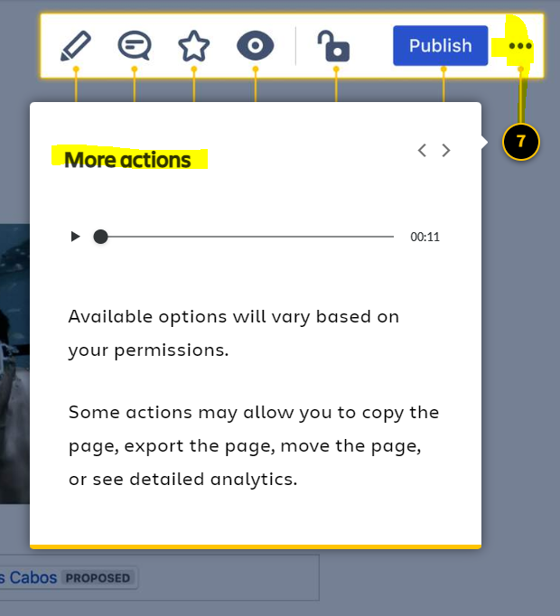

**How to find a page**

You may need to find a specific page in Confluence. Before you start looking, make sure you're in the correct space. Then, **there are three basic ways to find a page:**

**1. Use the page tree**

The **page tree** can be found within the space sidebar, under the header,*'Pages.'*Pages are organized in a hierarchy, visible in the page tree. Parent pages sit at the highest level. Child pages nest within the parents.

Click the arrow beside a parent page to reveal the child pages nested within.

👇 *Here's how to view the page tree and the pages within it.*

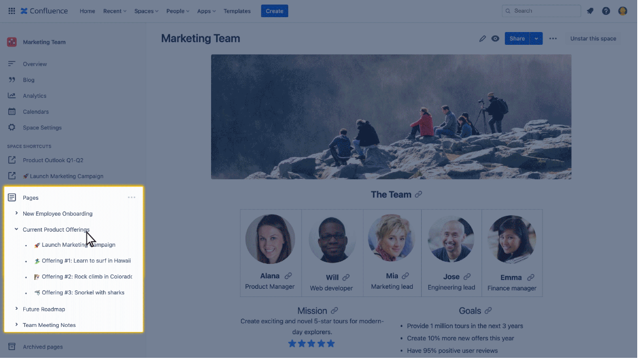The***page tree*** is located in the space sidebar and helps organize pages in a hierarchy.

**2. Use the search bar**

Another way to find pages is to use the search bar near the top right of the main navigation bar. Here are some tips for using it:

**🔍 Click in the search box to see recent work.**Before typing a single word, the search bar will populate a list of recent pages and spaces.

**🔍 Let Confluence guess your search.**As you type, Confluence tries to guess what you're searching for. Watch your screen for instant search results, even before you’ve finished typing.

**🔍  Can't remember the page name? Search for any related word.**Confluence will scan similar terms within the page to help you find what you're looking for.

👇*Here's an example of the search bar in action.*

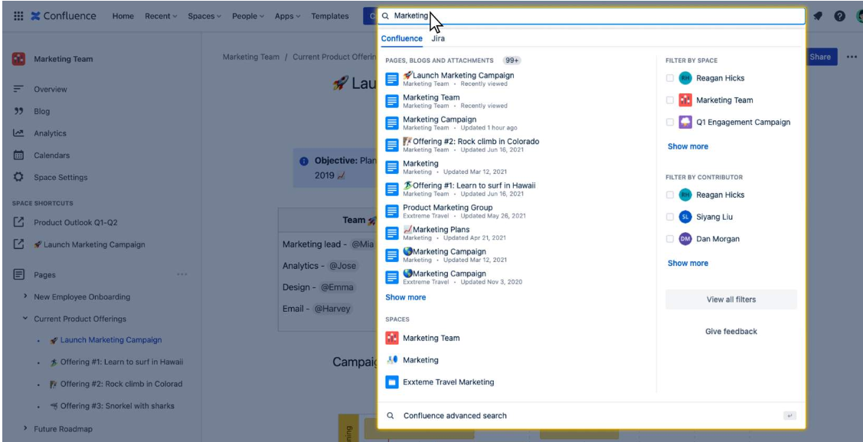**3. Go back to the homepage**

If you still can't find a page, navigate back to the homepage. Under the*'Recent'*header, you can click through the tabs to see pages you've recently visited, worked on, drafted, or starred.

👇 *Here's how to navigate back to the homepage and see your recent pages.*

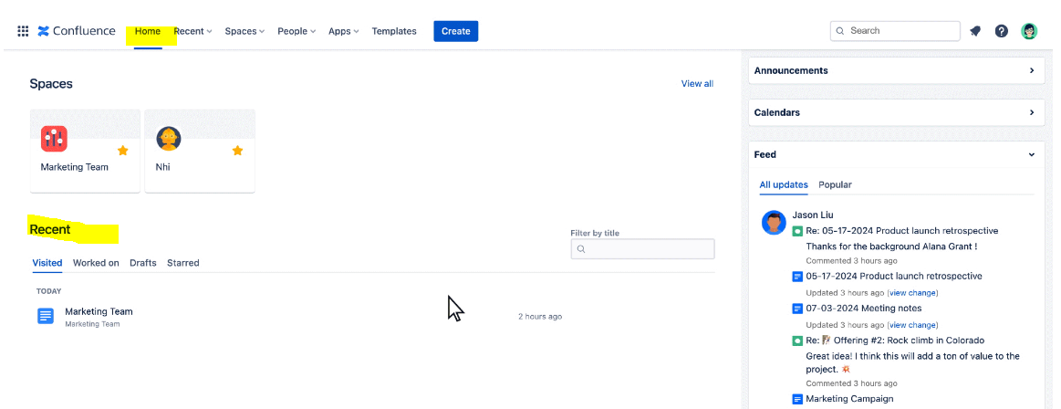**Ready to find a page in the page tree?**

**Open your Confluence and follow the steps below.**

* **1. Open the space sidebar:**If it's not already open, click to expand the collapsible space sidebar.
* **2. Find the page tree:** Identify the **'Pages'**header.
* **3. Select a page:**Scroll through the pages and select one to open it.

# Create your first page

**Ready to create your first page?**

**Know this before you do: every Confluence page lives online.**That means that anyone with access to your space can see what you publish. If you want only specific people to view your page, you can always change the permission settings as you'll learn soon.

**Here's something valuable to know:**Not everyone can create pages in Confluence. Some teams limit page creation to space admins only. If you don't see a *'Create'*button in your main navigation bar, you may not be able to create pages.

**How to create a page**

There are two main ways to create a page in Confluence: the**'Create' button** and the **page tree**. Watch the video below to learn how to create a page using both methods.

👇 *Click the play button to watch the video.*

**Tips to create your first page**

**1. There's no need to save your work manually.**

**As you edit your page, Confluence saves your work automatically.**Every page is saved as a draft that only you and your collaborators can see. Even if you close the page, your draft will be saved.

**You can find your saved drafts in the main navigation bar** by selecting *'Recent'* and toggling to *'Drafts.'*

👇 *Here's how to find your saved drafts.*

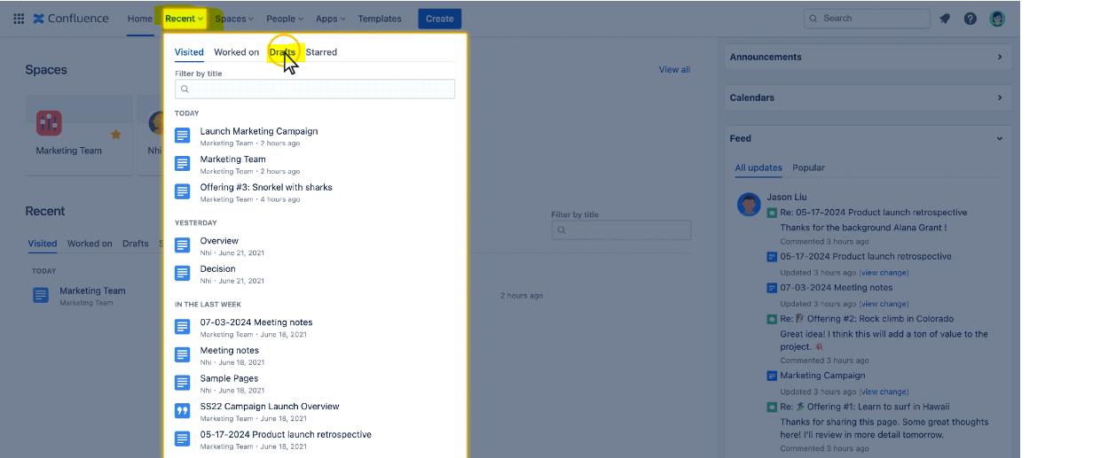To find the draft of a page you've worked on, click ***'Recent'*** then toggle to***'Drafts.'***

**2. You have full control over who can see your pages.**

**Notice the lock icon near the top right of your screen.** This is how you update page permission settings. You decide who can and cannot see your page.

**By default, your page will be set to 'Anyone can view and edit.'**Confluence is designed for transparency so everyone can access the information they need. That said, you may have control over these settings, depending on your own permissions.

Sometimes you'll want your entire organization to be able to view your page. Other times you'll want a private page only you can view.

👇 *To change page permissions, select the lock icon and choose an option from the dropdown.*

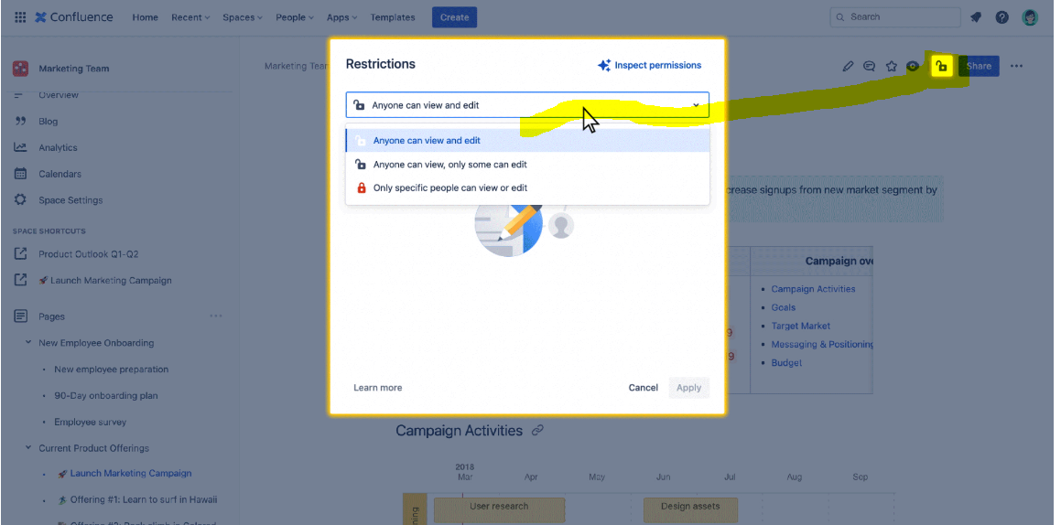Select the ***lock icon*** to update page permissions.

**3. Click the *'Publish'*button for your page to go live.**

**You must click the *'Publish*' button for your page to be viewable by your team.**When you click *'Publish,'* the page will reload, and you'll see the published version of your page.

The published page provides a new set of options near the top right of the page. Use these options to edit, share, comment on, and change permissions on your page. You'll learn more about these options in future courses.

👇 *Click the****'Publish'****button to make your page viewable by your team.*

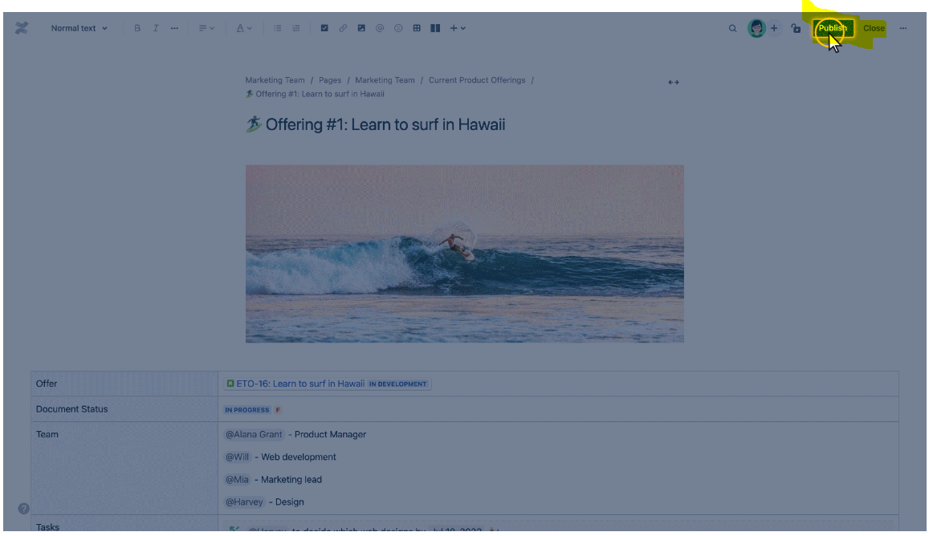**4. Find your new page in the *'Recent'* dropdown.**

**After publishing your page, it lives within the page hierarchy where it was initially created.**It may be nested within another page. One way to find your new page is to use the page tree.

If you can't find it in the page tree, go to the main navigation bar and select the***'Recent'***dropdown. Your new page should be near the top of the list.

👇 *To find your new page, select the****'Recent'****dropdown from the main navigation bar.*

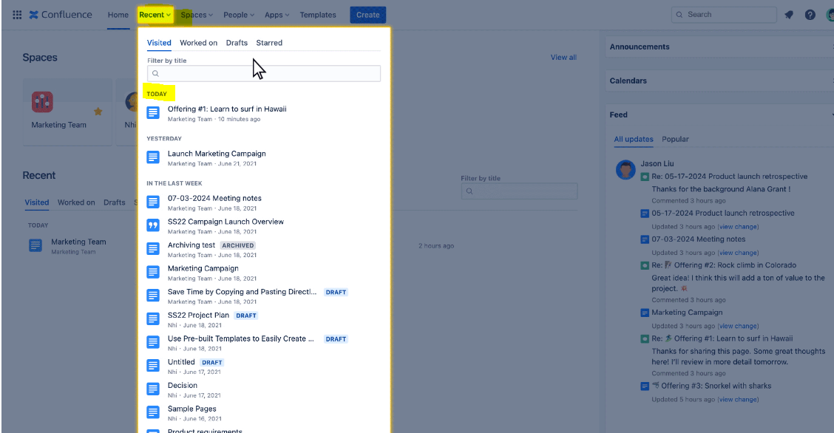

Click***'Recent'***to find your newly published page.

**Ready to create a page yourself?**

**Open your Confluence and follow the steps below.**

* **1. Select Create:** Click the **'Create'** button in the main navigation bar.
* **2. Add a title and content:**Enter a title and body content.
* **3. Select Publish:**Publish your page so your entire team can see it.











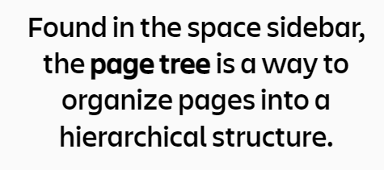





**✔ Page**  
A **page** is an editable document that communicates information.

**✔  Space**  
A **space**is a collection of related pages.

**✔  Main navigation bar**  
The **main navigation bar**is the menu at the top of your screen that stays with you wherever you go in Confluence.

**✔  Space overview**  
A **space overview**is the first page visitors see when they arrive at a space.

**✔  Space sidebar**  
On the left of your screen, the **space sidebar** is a collapsible menu that shows you options specific to the space you are viewing.

**✔  Page tree**  
Found in the space sidebar, the **page tree** is a way to organize pages into a hierarchical structure.

**✔  Starred pages**

You can add **'stars'**to your favorite (or most important) pages to make them easier to find later.

**✔  Watched pages**

You can **'watch'**pages to get email notifications when changes or comments are added to the page.

**What's the best way to get around in Confluence?**

Let's start with these two menus:

* the  **main navigation bar**at the top of your screen
* the **space sidebar**on the left of your screen

You learned a bit about these navigation menus in the introductory course, *Get started with Confluence*. Today we'll go deeper, exploring each menu option and its capabilities.

👇 *Click the + icons for a preview of both navigation menus. Then scroll below to learn more.*

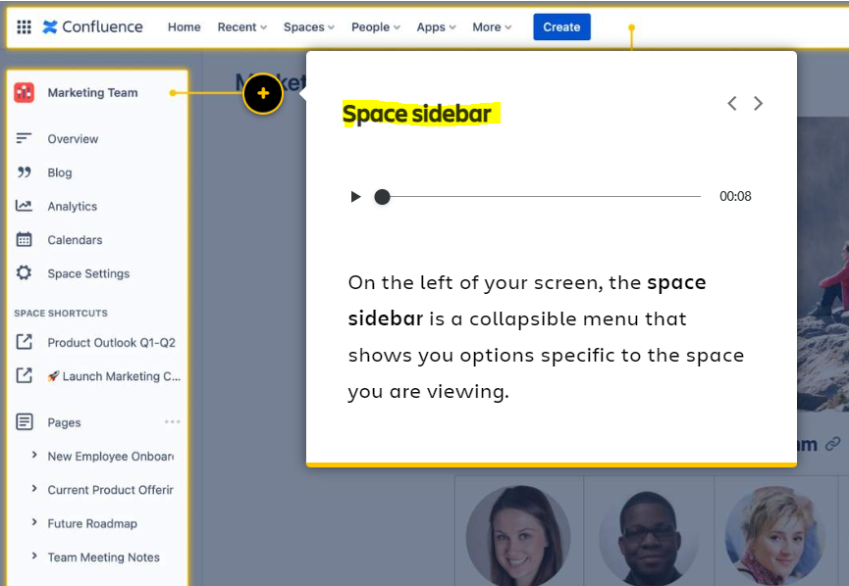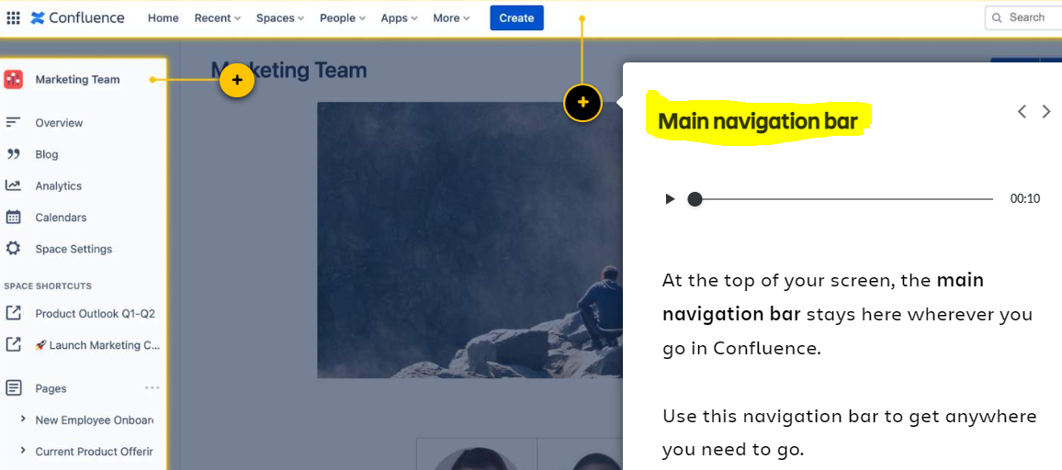

**Here's something valuable to know:**The options within your navigation bars may look different than the screens in this course. Navigation options can be customized based on your space settings, permissions, and team preferences.

**What's in the main navigation bar?**

**Find out what each option and dropdown is all about.**

👇 *Click the number icons to learn about each option in the main navigation bar.*

1. 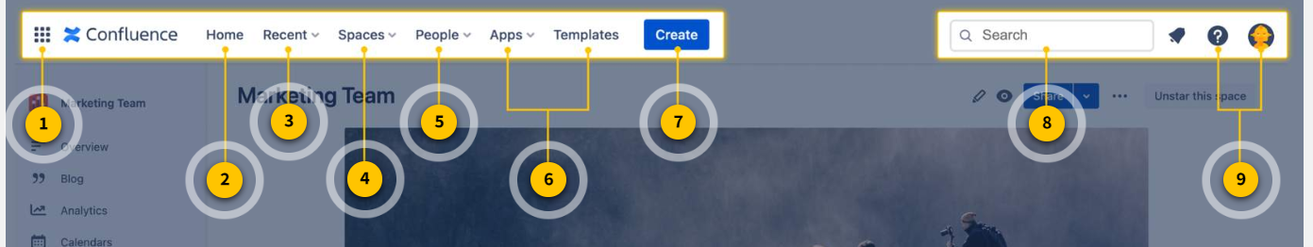**Product switcher:** Allows you to switch to other Atlassian products your team may be using, like Jira or Bitbucket.
2. **Home**: Navigate to the Confluence homepage to easily access spaces and pages most important to you.
3. **Recent:**Shows pages you’ve recently visited and worked on, drafts, and starred pages.
4. **Spaces:**Easily switch to a different space.
5. **People:** Shows a list of the people and teams you interact with most.
6. **Apps and Templates:** Access content from apps like calendars and analytics. See the full library of Confluence templates.
7. **Create:** A quick way to create new pages.
8. **Search:**Text-based search field to help you find pages, spaces, and people.
9. **Profile and settings:** Customize your personal settings, set up your profile, and control email notifications.

**What's in the space sidebar?**

**More options and dropdowns to help you navigate!**

👇 *Click the number icons to learn about each option in the space sidebar.*

1. 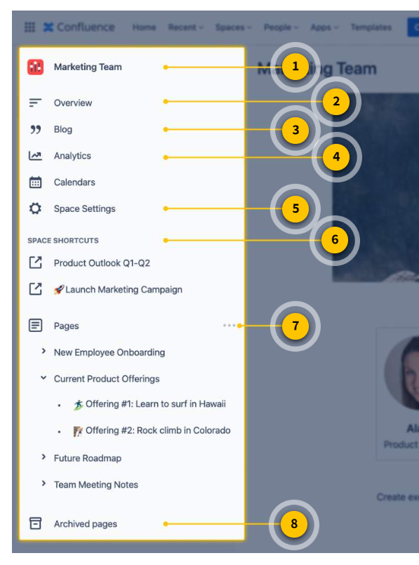**Space name:** Shows the current space you are in.
2. **Space overview**: The first page visitors see when they arrive at a space. Space overviews can be fully customized to fit the needs of your team.
3. **Blog:**Brings you to a list of blog posts within this space.
4. **Analytics:**View space analytics. See the most popular pages, most active readers, and most active contributors.
5. **Space settings:** Update space settings such as name, logo, categories, and administrators. As a Confluence user, you may not have access to edit the space settings.
6. **Space shortcuts:** Add a shortcut to important pages you access often.
7. **Page tree:** The page tree a helpful tool to find and organize pages. Parent pages sit at the highest level. Child pages nest within the parents.
8. **Archived pages:**This feature allows you to archive outdated content and store it away from your daily workspace.

**Ready to navigate Confluence yourself?**

**Open your Confluence and follow the steps below.**

* **1. Open a recent page:** On the main navigation bar, select '**Recent**.' Select a page you've recently worked on.
* **2. Switch to a different space:**On the main navigation bar, click the '**Spaces'** dropdown. Select a space from the list.
* **3. Find the page tree:**On the space sidebar, scroll to the '**Pages'** header. Select a page.

**Pages vs. blog posts**

There are two main types of content you can create in Confluence: **pages** and  **blog posts**. What's the difference?

**📖  Pages**

**Pages**are best for evergreen content - brainstorming, project planning, collaborating and creating long-term content across your organization. Pages can be structured in a hierarchy to show relationships, making them easy to find and organize. You'll probably use pages more often than blog posts.

**💬  Blog posts**

**Blog posts** are best for short-lived content - sharing timely announcements, updates, and news. They are ordered chronologically and can be accessed from the *'Blog'* section in the space sidebar. Blog posts work well to share any timely updates or news with your organization.

**👇***Here is an example of a page and a blog post. Notice the difference in how they are used.*

**Save time with page templates**

When you create a new page, you can start from a blank page or a page template.  **Page templates**are pre-formatted pages that include guided instructions. They provide a starting place to save you time and keep your content well-organized. Confluence has over 75+ templates for you to choose from.

**To use a template,** first create a new page. A panel will open on the right side of your screen. This panel provides a list of templates for you to browse. Watch the video below for tips to create a page with a template.

👇 *Click the play button to watch the video.*

**Find the right template for you**

**There's a Confluence template for every need.** Business strategy. Marketing. Productivity. Human resources. Product management. Software development. With so many options, how do you find what you're looking for?

**Here are a few tips to find a template:**

* **Type in the search box** to find a template that fits your needs
* **Select the category bubbles** to filter quickly
* **Hover your cursor over a template** to see a preview

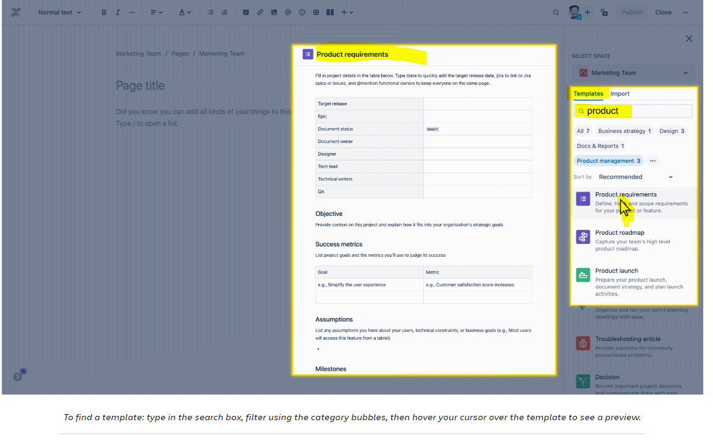**Add content and publish your page**

**Your template is selected. Now it's time to add content to your page.**Page content can include text, emojis, tables, multimedia, and more. You'll learn how to add these enhancements in the next lesson.

As you make edits, your page is automatically saved as a **draft**. A draft is an unpublished page only you can see. Drafts will not show up in the search results. To find your drafts, use the main navigation bar and select*'Recent' > 'Drafts.'*

When your page is ready, it can be **published**. That means anyone in the space can view, comment, and **edit**your page (if they have sufficient permission).

Watch the video below to learn more about **drafting**, **editing**, and **publishing** pages in Confluence.

**Ready to draft and publish a page?**

**Open your Confluence and follow the steps below.**

* **1. Create a new page:** Click the ***'Create'***button from the main navigation bar.
* **2. Choose a template:**Browse templates and select one that fits your needs.
* **3. Make edits and publish:**Add content and click publish when you're ready.

**Improve your pages with clean formatting and dynamic elements.**

**When your page is in edit mode, the toolbar allows you to make enhancements to your page.**You can format text, change layouts, add emojis, create tables, upload multimedia, and more.

👇 *Here is a page using many enhancements from the toolbar. Scroll below to learn how to build one yourself.*

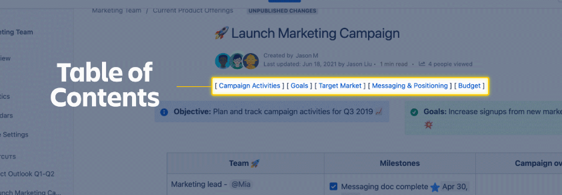

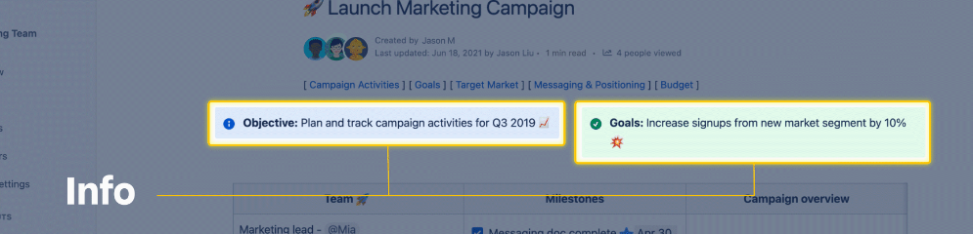

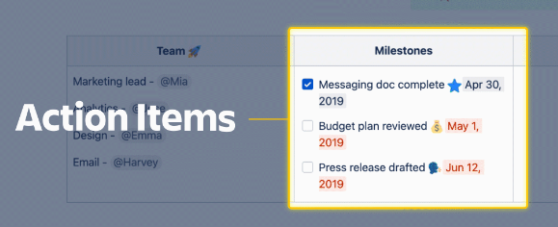

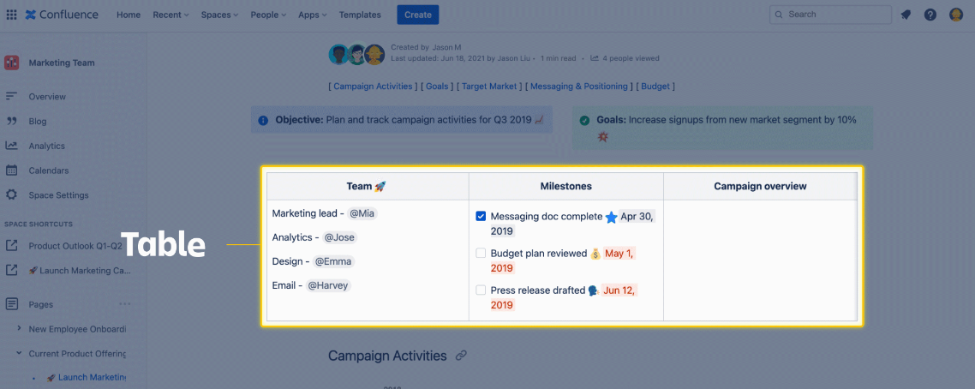

**Format your text**

**Formatting text is a simple way to clarify your message and call attention to important information.**In edit mode, the toolbar can be found the top of your screen. The left side of the toolbar provides text formatting options.

Use the text styles dropdown to select various heading and paragraph styles. Add emphasis to text with options such as bold, italics, underline, text alignment, and color.

👇 *Here is how to access the text formatting options.*

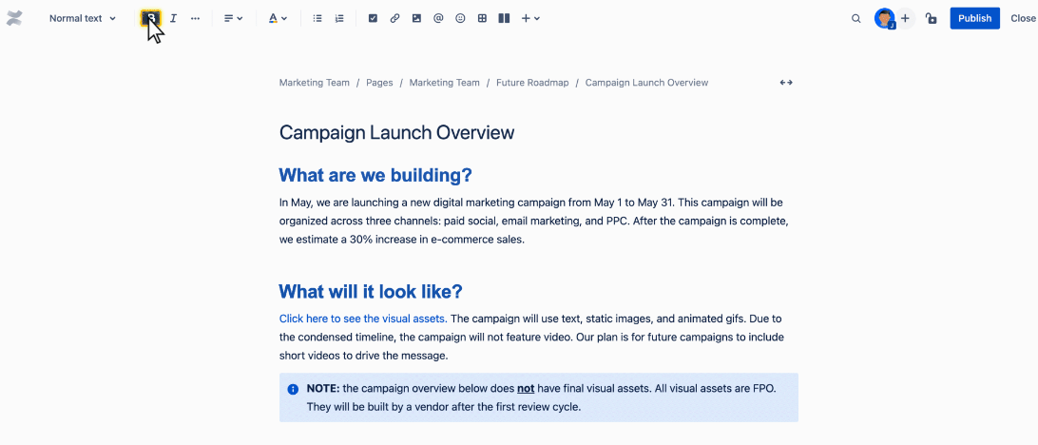

Update text formats using the toolbar at the top of your screen.

**Try these other formatting options**

**The toolbar can do much more than format text.**On the right side of the toolbar, there are additional options to improve your page. Here you can add action items, links, multimedia, @mentions, emojis, tables, layouts, and dynamic elements called  **macros**. You'll learn more about macros next.

👇 *Click the numbers to learn more about the additional formatting options.*

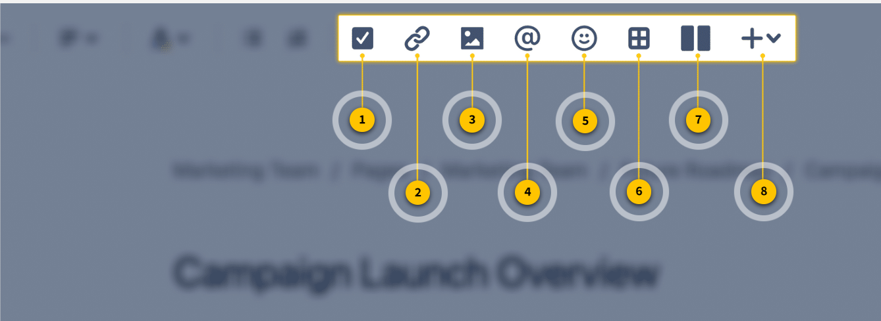

1. **Action item:** Use **action items**to assign work to teammates. When you @mention a teammate next to the action item, that item will be assigned to them.
2. **Add a link**: To **add a link**, select a line of text on the page. Then, click this link icon in your toolbar. Paste the URL you'd like to link.
3. **Add multimedia:**Upload **multimedia** to your page, like images and videos.
4. **Mention a teammate: Mention teammates** to notify them about your page. To mention a teammate, click this @ icon and type a teammate's name. When your page is published, your teammate will receive a notification.
5. **Add an emoji:** Add an **emoji** to give your page extra style. Select this icon to choose from a list of emojis. You also have the ability to upload your own.
6. **Add a table:** Add a 3x3 **table** to your page. You can add or remove columns and rows as needed.
7. **Change the layout:** Select between a few different column **layouts** for your page.
8. **Add a macro:**Add a **macro**: a small tool that extends the capabilities of a Confluence page.

**Here's something valuable to know:**You can also add multimedia files by dragging and dropping them onto the page. Drag images or videos directly onto the page and they will automatically be embedded.

**What is a macro?**

**A  macro  is a tool that extends the capabilities of a Confluence page.**You can think of macros as similar to "plugins." They allow you to add extra functionality or include dynamic content on your page.

**To add a macro,** make sure your page is in edit mode. On the toolbar, select the + dropdown. Select one of the macros to add to your page.

👇 *Here's how to add a macro to your page.*

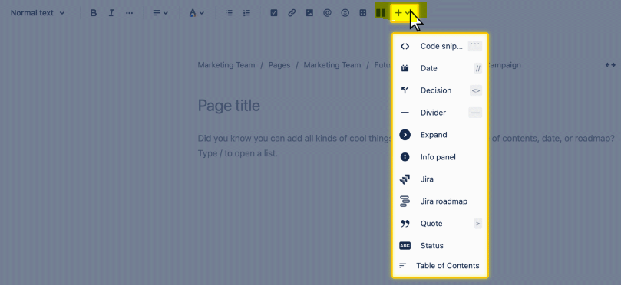

To add a ***macro***, click the + dropdown and select a macro from the list. In the example above, an 'info panel' macro is added to the page.

**Here's something valuable to know:**Another quick way to add a macro is to type **/** in the body of your page. This will open a list of available macros for you to choose from.

**Not sure where to start? These are the most popular macros:**

👇 *Use the****/ key and the text command****to add any macro to your page.*

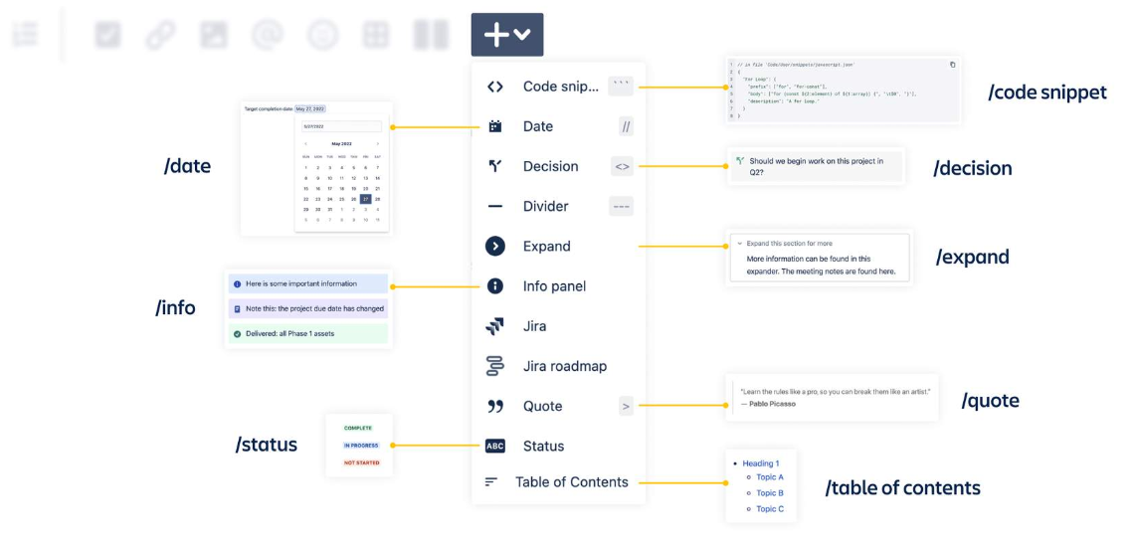

**See how formatting and macros come together**

**Watch the video below** to see how formatting, multimedia, and macros are used together to create an enhanced page experience.

👇 *Click the play button to watch the video.*

**Ready to enhance your page?**

**Open your Confluence and follow the steps below.**

* **1. On any page, enter edit mode:** Select the edit icon at the top right of your screen.
* **2. Update text styles:**Add a header and change paragraph text.
* **3. Add multimedia:**Use the icon to upload an image or video to your page.
* **4. Add a macro:**Use the + dropdown or type / to select a macro.

# Organize and find pages

**How to move and organize pages**

**Confluence gives you full control over how your pages are organized.**This makes it easy for anyone on your team to find what they need. There are two main ways to move pages within a space:

* Use the**page tree**
* Use the ***More actions (•••)****menu*

**👇***Here's how to access the****page tree****and the****More actions****menu.*

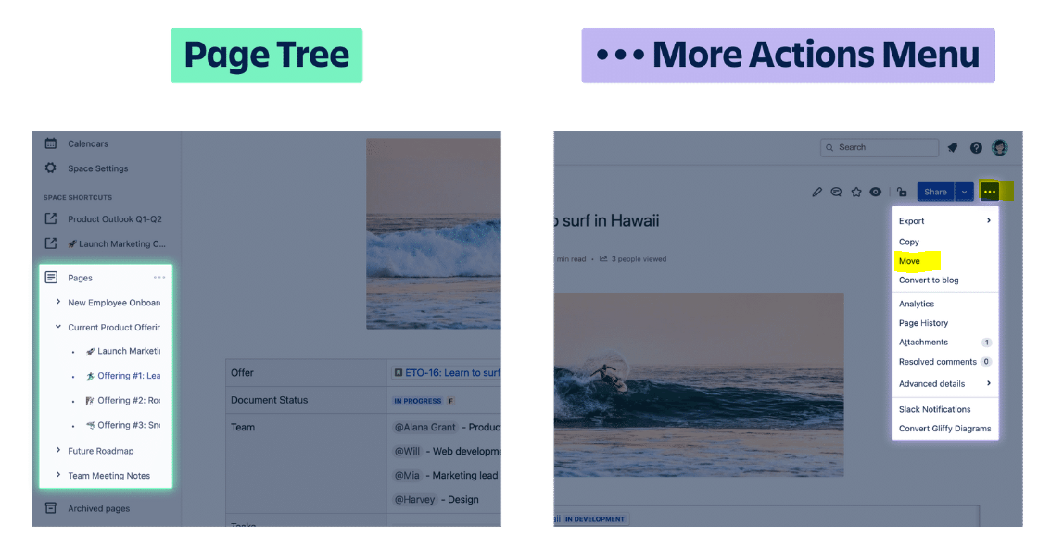

**Move a page using the page tree**

**This option works best if you need to quickly move or reorder multiple pages.**Here's how to move a page using the page tree:

1. **Expand the space sidebar** and locate the page tree
2. **Click the arrows to expand** and find a page you'd like to move
3. **Drag and drop the page** to a new position in the page tree

👇 Here's how to move a page using the page tree.

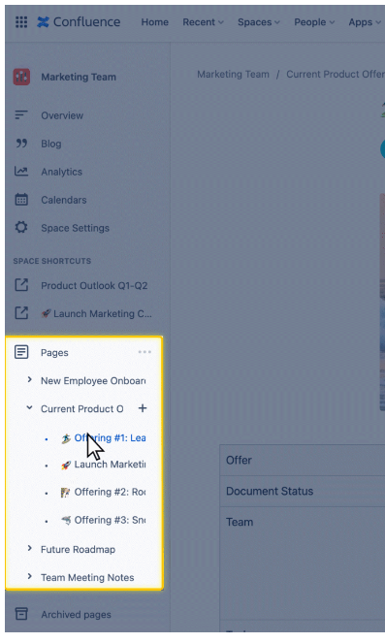

Reorganize pages in the page tree by dragging and dropping them.

**Move a page using the More actions (•••) menu**

**This option works best if you need to move a page you are currently viewing.**Or if you aren't able to easily locate the page in the page tree. Here's how to move a page with the More actions menu:

1. **Click More actions** ***(•••)*** near the top right of your screen
2. **Select *Move***
3. **Drag and drop the page** to a new position in the hierarchy

👇 Here's how to move a page using the ***More actions (•••)*** menu.

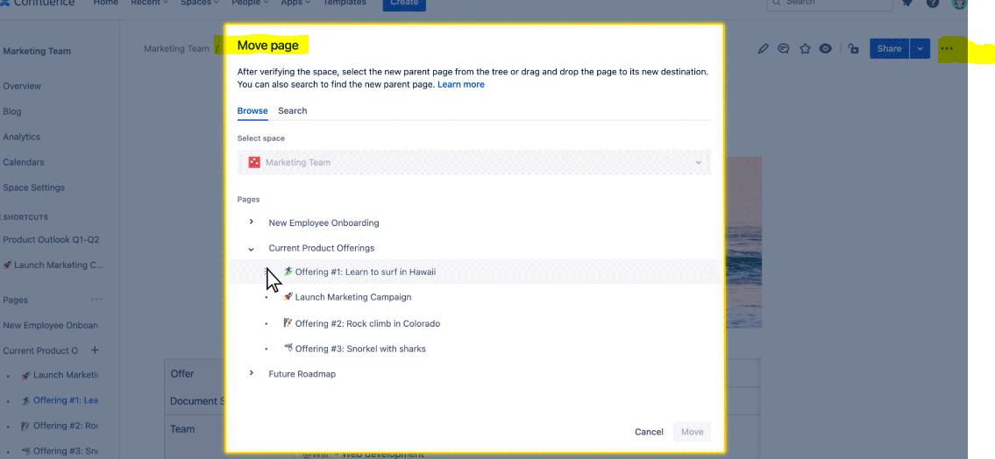

**Here's something valuable to know:**When you move a page, all incoming links will stay the same. When you move a parent page, the entire hierarchy of child pages moves too.

**Find pages with advanced search**

As you've learned previously, the most common ways to find a page are the search bar, basic search, or *'Recent'* dropdown. **If you *still* can't find a page, use  advanced search .**

With advanced search, you can refine results using search syntax (special words and symbols). Using syntax allows you to search for exact matches, search for keywords using operators, and search for keywords using wildcards.

To start your advanced search,

1. **Click the search bar** at the top right of the screen
2. **Select*'Confluence advanced search'***

👇*Here's how to start your advanced search.*

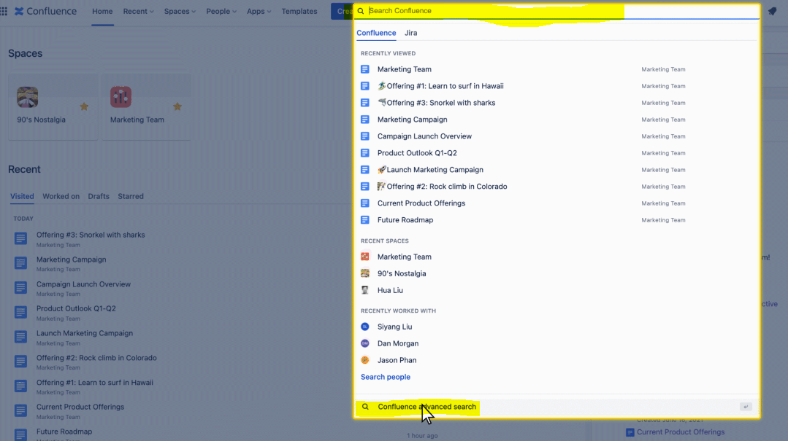

Start your advanced search by clicking the search bar, then 'Confluence advanced search.'

**Search for exact matches**

**To find a page that contains an exact phrase, use double quotes around your search phrase.**

For example, searching for **"product manager"** in double quotes will show search results with that exact match. Results will *not* contain pages that have only 'product' or only 'manager.'

👇*Here's how to search for an exact phrase match.*

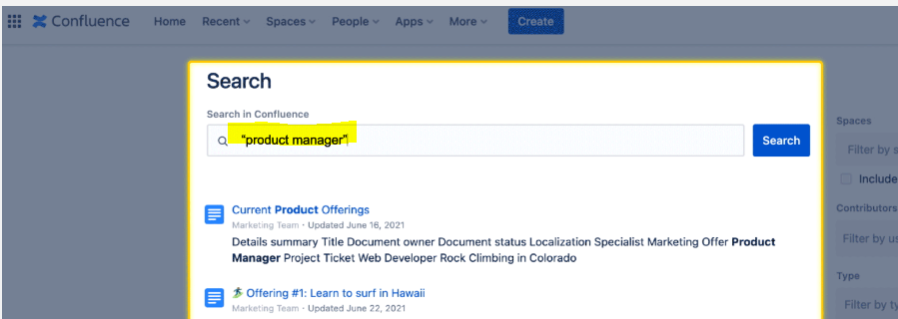

Use double quotes to search for an exact phrase.

**Search with operators**

If you don't know the exact phrase you're looking for, enter keywords and operators in the search field. The available operators are OR, AND, NOT, and Group.

* **OR search:**searching for **'marketing' OR 'digital'**will show results that contain one of these terms.
* **AND search:**searching for **'marketing' AND 'digital'**will show results that contain both of these terms.
* **NOT search:**searching for **'marketing' NOT 'digital'** will show results that only contain 'marketing' and do not contain 'digital.'
* **Group search:**searching for **(marketing OR digital) AND content**will show results that can contain either 'marketing' or 'digital,' but must contain 'content.'

👇*Here's how to search using operators.*

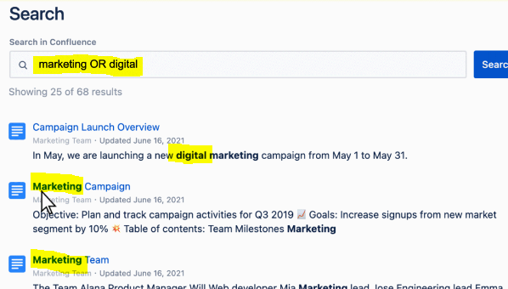

Use operators such as ***OR, AND, NOT,***and***Group*** to narrow your search.

**Search with wildcards**

**A wildcard is a character like ? or * that can be used to replace characters in your search. To replace a single character, use ?. To replace multiple characters, use *.**

* For example, a search of **b?g**will show pages that have any of the following words: big, bug, bag, beg, or bog.
* A search of **manag\*** will show pages that have words such as: manage, manager, management, managing, managerial, etc.

👇*Here's how to search using wildcards.*

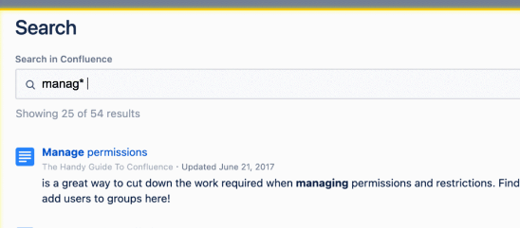

Use wildcards such as ***?***or ***\****to replace characters in your search.

**Here's something valuable to know:**You can combine exact matches, operators, and wildcards in one search query. For example, you can search  manag* AND past? AND ("article" OR "post")

**Ready to try advanced search?**

**Open your Confluence and follow the steps below.**

* **1. Navigate to advanced search:** Click the search bar, then**'Confluence advanced search.'**
* **2. Use Confluence syntax:**Use syntax for exact match, operators, or wildcards.
* **3. Click search:**Click **'Search'** to see your results.

# Collaborate with your team

**Edit pages in real-time**

You and up to 12 teammates can edit a page at the same time with **collaborative editing**. In real-time, you can see which teammates are working on the page and see every edit as it happens. It's a great way to get work done together, quickly and efficiently.

**To start collaborative editing,** select the edit button on any page. Invite a teammate by selecting the circular + option next to your profile picture. As your teammate begins making edits, you'll be able to see their changes as they happen.

👇 *Here's collaborative editing in action.*

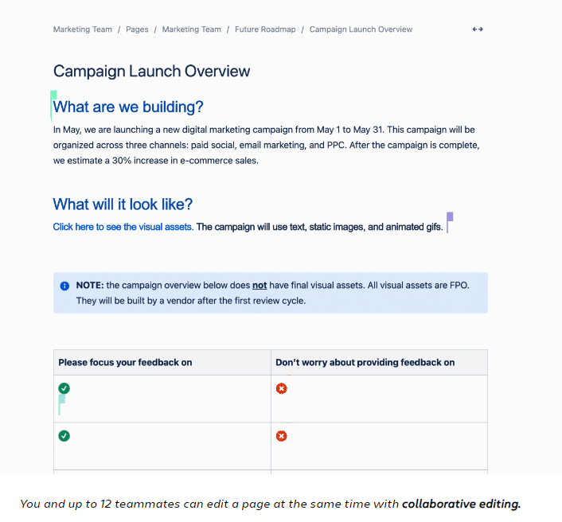

**Use comments and mentions**

C**omments** and **mentions** and powerful features to collaborate with your teammates. You'll use both features often to give feedback, ask questions, and bring your entire team into the conversation.

**How do comments and mentions help you at work?**

**✅ They save you time and make you more efficient.**Comments allow you and your team to work asynchronously. Everyone saves time, limiting back-and-forth emails and unnecessary meetings.

**✅ They help you gain new perspectives and ideas.**With comments, more teammates can get involved in brainstorming and ideating. These fresh perspectives give projects the best chance for success.

**✅ They create a culture of openness and support.**Using comments provides transparency and openness across your team. This builds trust amongst teammates and creates a positive team culture.

You can use comments and mentions in a few different ways in Confluence. Scroll below to learn how to add **page comments**, **inline comments**, and **mentions**.

**Add page comments**

One way to use comments is to add a comment to an entire page. Here's how:

1. **Scroll to the bottom of the page**
2. **Type a comment in the comment field**
3. **Select Save**

When you comment on a page, you will automatically start 'watching' that page. That means you'll receive email notifications when others add comments or changes to the page are made. Your teammates can reply to or 'like' your page comments. If they do, you'll be notified.

👇 *Here's how to add comments to a page.*

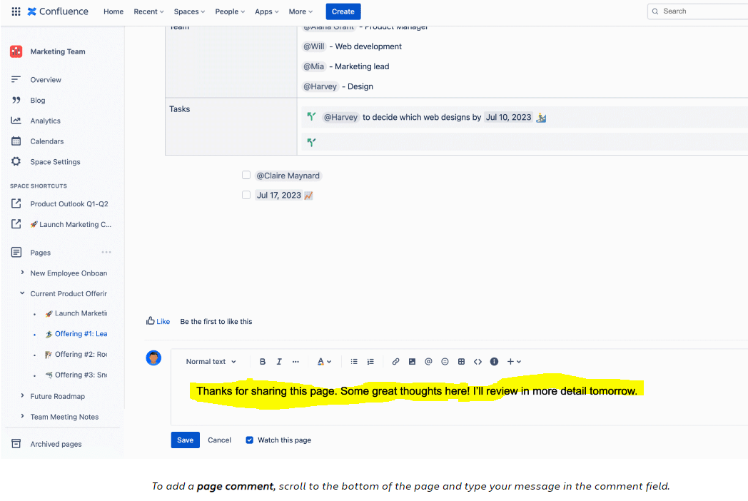

**Add inline comments**

You can also add comments *within* the page, inline on any text. Inline comments can be added when you are either editing or viewing a page. Here's how to add an inline comment:

1. **Highlight the text you'd like to comment on**
2. **Click the comment icon that appears above the highlighted text**
3. **Type your comment and select Save**

After you save your comment, the text on the page will be highlighted in yellow. To view comments, click any yellow highlighted text on the page. Just like page comments, your teammates can reply to or 'like' your inline comments.

👇 *Here's how to add inline comments on a page.*

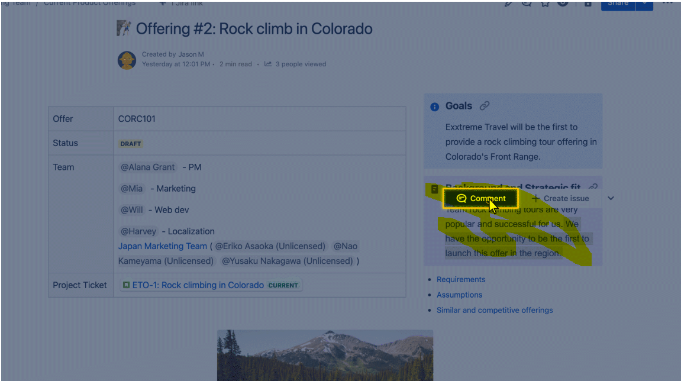

**Mention teammates**

Mentioning teammates (often called @mentioning) helps bring attention to important information. You can @mention teammates **on a page** or**in a comment.**

📖 To @mention a teammate on a page:

1. **Make sure your page is in edit mode**
2. **Type the @ key and wait for a list to populate**
3. **Start typing your teammate's name and select it from the list**

💬 To @mention a teammate in a comment:

1. **In the comment field, type the @ key**
2. **Start typing your teammate's name and select it from the list**

When you @mention a teammate, they will receive an email notification with a link to the page.

👇 *Here's how to @mention a teammate on a page and in a comment.*

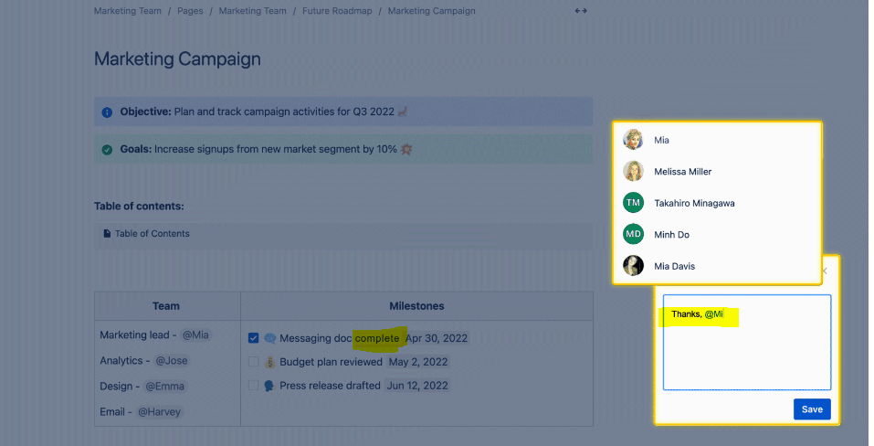

You can @mention teammates ***on a page*** or**in a comment.**The example screen above shows how to do both.

**Here's something valuable to know:**Comments don't appear to viewers until the page is published. Any teammate mentioned in a comment won’t be notified until you publish the page.

**Share pages with teammates**

**You'll often need to send pages to teams or individuals.**The *'Share'*button at the top right gives you two easy ways to share a page:

1. **Share by name, group, team, or email:**Enter a teammate's name or email. Type a quick message. Select *'Send.'*
2. **Copy the link:**Select *'Copy link'* to copy the URL. Paste the URL in an email or messaging app to share with teammates.

👇 *Click the play button to watch the video about sharing pages.*

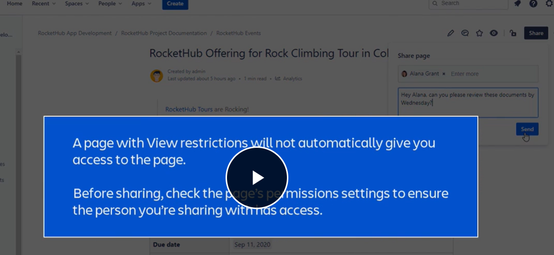

**Here's something valuable to know:**Another way you can share a page is to copy and paste the URL from your browser.

**Ready to start collaborating in Confluence?**

**Open your Confluence and follow the steps below.**

* **1. Add an inline comment:** On any page, highlight a line of text and select the comment icon that appears above.
* **2. Mention a teammate:**In the comment, use the @mention feature to mention a teammate.
* **3. Share the page:**Select the **'Share'**button and enter a teammate's name or copy the link.

**✔ Main navigation bar**  
At the top of your screen, the**main navigation bar** stays here wherever you go in Confluence. Use this navigation bar to get anywhere you need to go.

**✔  Space sidebar**  
On the left of your screen, the **space sidebar** is a collapsible menu that shows you options specific to the space you're viewing.

**✔  Blog post**  
Different than pages, **blog posts** are another type of content you can create in Confluence. They are best for sharing announcements, updates, and news.

**✔  Page templates**  
**Page templates**are pre-formatted pages that include guided instructions. They provide a starting place to save you time and keep your content well-organized.

**✔  Macros**  
**Macros** are small elements that extend the capabilities of a Confluence page. They allow you to add dynamic content or extra functionality to your page.

**✔  Advanced search**  
**Advanced search**allows you to refine results using search syntax: special words and punctuation marks. Search for exact matches, search for keywords using operators, and search for keywords using wildcards.

**✔  Collaborative editing**

**Collaborative editing**allows you to edit pages with your teammates in real-time.It's a great way to get work done quickly and efficiently.

**With every Confluence page you create, your goal is to engage readers and communicate effectively.**To achieve this goal, you must improve two aspects of every page: your writing and the visual elements you select.

* Your writing must be clear and concise.
* The visual elements must be purposeful, supportive, and boost the clarity of your message.

Let's take a look at the best practices for **creating engaging content.**

**Tips to create engaging content**

**1. Start with an outline (or a template)**

**Organize your ideas into an outline before you begin writing.**An outline helps you connect ideas and keeps you on track. It ensures your final Confluence page is clear, concise, and compelling.

**How do you create an outline?**One simple method is to document your main idea and the desired outcome of the page. Think, *"What is my single main idea?"*And then, *"What do I want readers to do or understand after they read this page?"* Answer these big questions first. Then fill in your outline with supporting ideas.

**Another easy way to create an outline is to use a Confluence page template.**Templates often come with an outline built-in, pre-formatted, and ready for you to fill in.

👇 *Confluence templates often come with a built-in outline. Here's an example.*

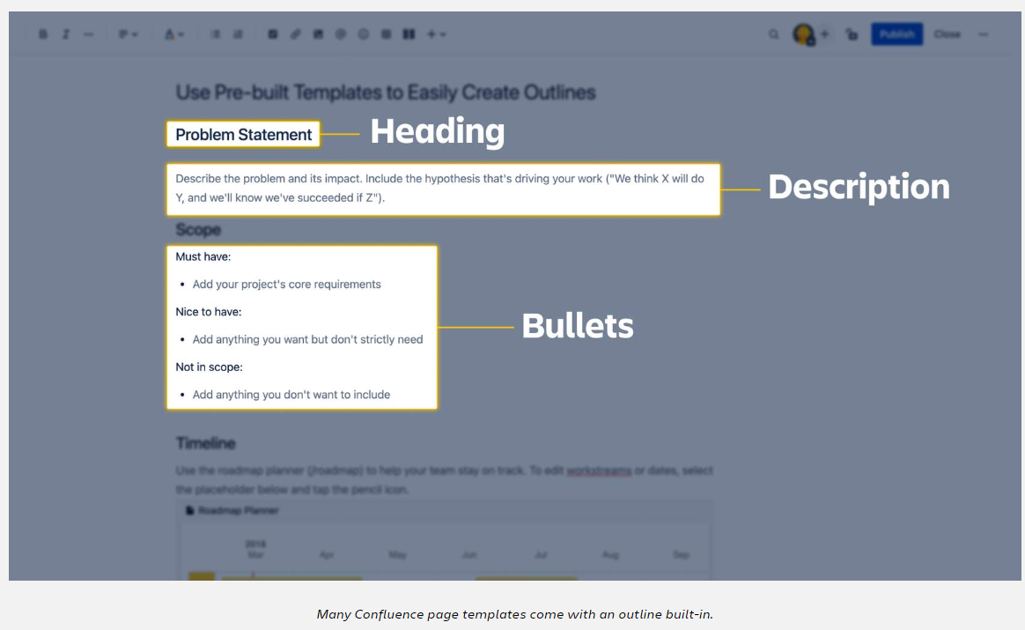

**2. Know your target audience**

**Before you begin writing, know who you're writing for.**Is this page for yourself? Your manager? Your entire company? Each audience requires a different tone and message.

If it's for your manager, you might adjust the tone to align with their communication style. If it's for your entire company, you might simplify the message and keep all language concise.

**Expert tip:** To keep your target audience top of mind, add a short line of text to your page to remind yourself of the audience. This makes it easy for you to adjust your message and tone as you're writing. Just make sure to delete the line of text before you publish.

👇 *Always keep your audience top of mind when creating a page.*

**3. Keep sentences and paragraphs short**

**Short sentences increase reader comprehension.**Large blocks of text can be overwhelming. Keep every sentence and paragraph short, simple, and concise.

How long should each sentence be? **Aim for 8-20 words.**

How long should each paragraph be? **Aim for 2-4 sentences.**

**Why?** When sentences are short, reading comprehension levels soar. For sentences that are 14 words long, readers comprehend 90% of the information. When sentences are 42 words long, comprehension declines to 10%.

👇 *Here's an example of a Confluence page using short sentences and paragraphs.*

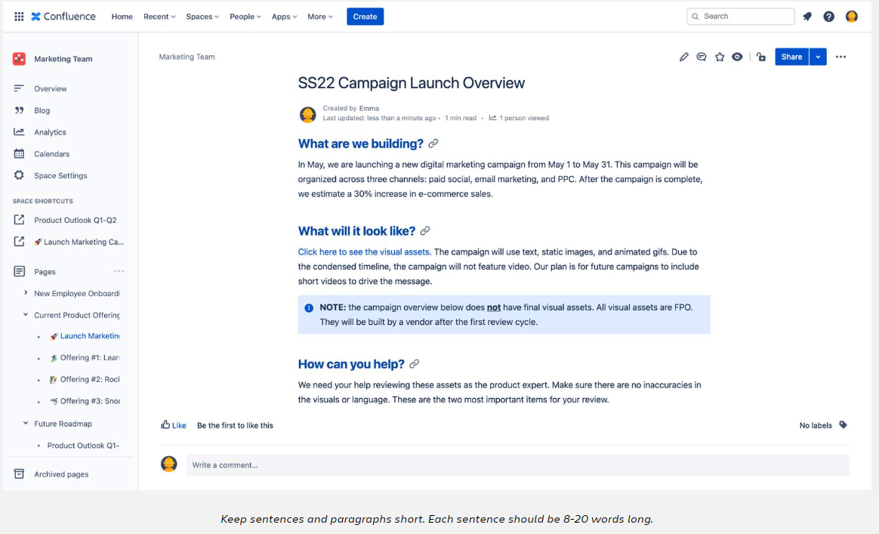

**4. Choose visual elements wisely**

**Don't fill your page with unnecessary macros.**This is a common pitfall for beginners. Every visual element should have a purpose - to help communicate your message more clearly. Here are a few of the most popular visual elements and how they can be used:

* Use the **info panel macro**to call attention to critical information
* Use a **table of contents macro** to allow readers to jump to different sections of your page
* Use a **table** to organize complex information into columns and rows
* Use the **status macro**to provide updates on projects and work items
* Use **images and emojis** to add clarity and break up long text blocks

**Expert tip:**When editing a page, use the slash command (press the / key)to open a dropdown menu of elements to add to your page.

👇 *Here is an example of visual elements used wisely in Confluence.*

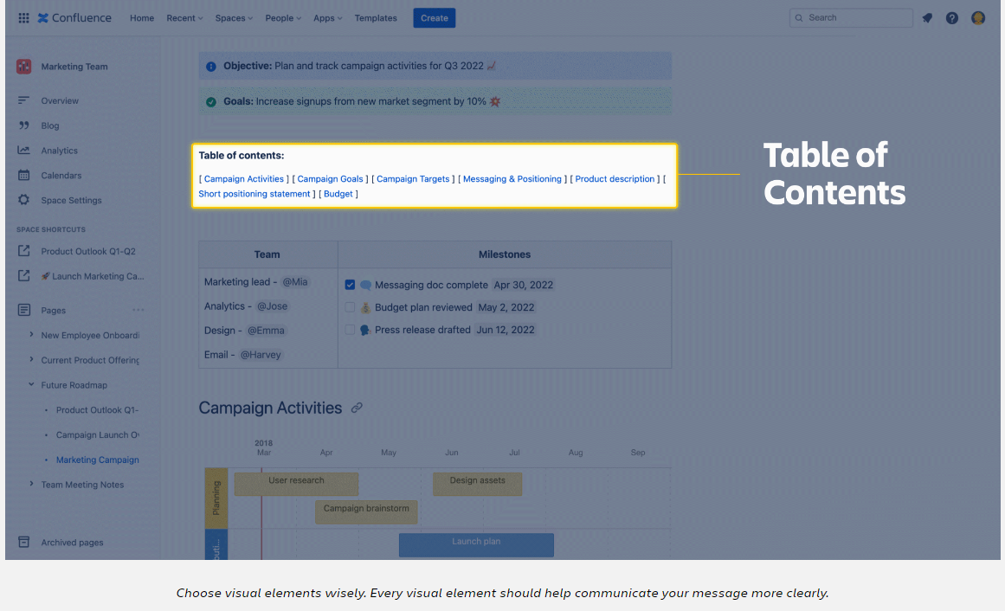

**5. Add a table of contents**

**Let readers jump to specific sections of your page with a table of contents macro.**This macro uses the page headings to create a clickable table of contents. There are two ways to create a table of contents, just like any macro:

1. **Use the toolbar:** Select the + icon in the toolbar, then select the Table of Contents macro.
2. **Use the / command:** Press the / key, start typing '*table of contents'* and select the macro from the filtered pop-up list.

Your table of contents will be added, but it won't be visible until the page is published. You can edit and preview the table of contents by selecting the pencil icon. Here you can adjust the settings such as output type and list style. And you can see a preview before publishing.

👇 *Here is how to add a table of contents using the toolbar + icon.*

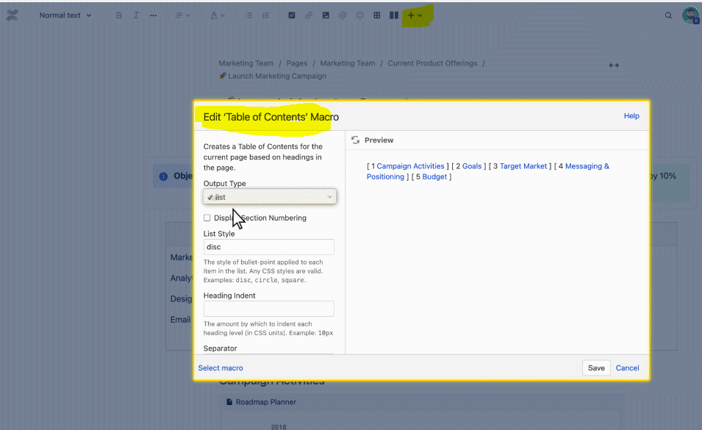

Add a table of contents so your readers can jump around your page. You can edit and preview the table of contents by selecting the pencil icon.

**6. Copy and paste content from design programs**

**Confluence makes it easy to add graphics and images from popular design programs.**

You may want to add a bar chart from a Keynote presentation. Or an image from Keynote. Copy the item from the program and paste it into your Confluence page — no need to save the image as a separate file.

👇 *Copy and paste content from your design program into Confluence.*

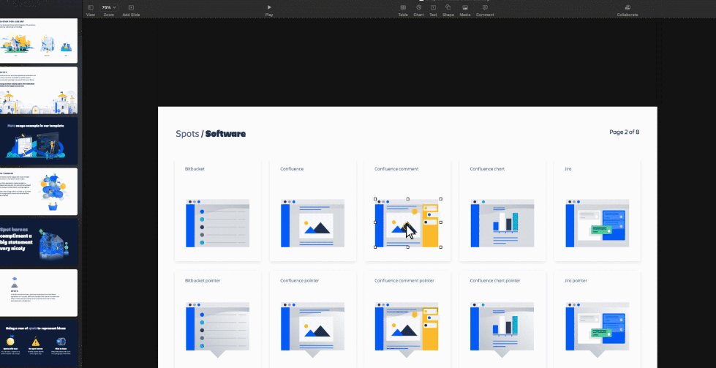Copy and paste images from design programs directly into Confluence.

**Confluence is loaded with features to help you be more productive in your job.**Whether you're using shortcuts to build content more quickly or using parent pages to stay organized, Confluence helps you get more done in less time.

Let's learn the best practices for **efficiency** and **organization**in Confluence.

**Tips to be efficient and organized**

**1. Copy a page to save yourself time**

**Often the best way to create a new page is to start from an old one.**Make a copy of any page to save time. Here's how:

* Navigate to any page and select ***More actions (•••)***
* Select ***Copy***
* Pick a location for your new page and select***Copy***

**Expert tip:**You can copy a parent page with all the child pages. Instead of duplicating each page one by one, you can copy the entire tree of pages. To do so, when you follow the steps above, check the box labeled ***Include child pages***.

**👇***Here's how to make a copy of a page.*

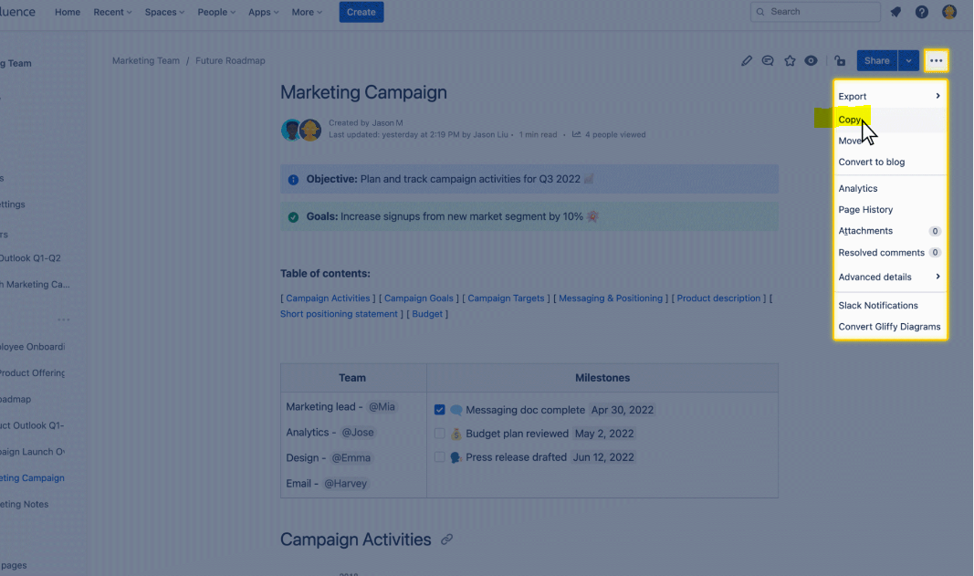

Copy a page to save yourself time.

**2. Create your own page templates**

**An alternative to copying pages is to build a custom page template in your personal space.**Here's how:

* Navigate to your personal space overview
* In the space sidebar, select ***Space settings***, then***Content tools***
* Select the ***Create new template***button

Design your template and select Save. The next time you create a new page in this space, your template will be available in the right panel.

**Important note:** Your custom page templates can*only* be used in the space you've created them in. If you're primarily creating pages in shared spaces, you may find the page copy option (#1 above) more valuable.

**👇***Here's how to create your own page template.*

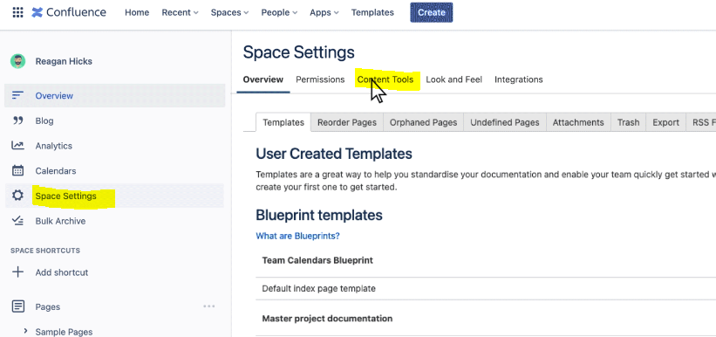

You can create custom page templates in your personal space.

**3. Add labels so pages are easy to find**

**Labels are keywords you can add to pages to make them easier to find.**They help boost the visibility of your page in the search results, giving your page a better chance of being read.

For example, you can add an "onboarding" label to all pages related to welcoming new employees. A search for "onboarding" will return every page with this label. Here's how to add a label to a page:

* Make sure you're in edit mode, then select ***More actions (•••)***
* Select ***Add labels***
* Type each label and click ***Add***

**Expert tip:**Labels work best when everyone on your team uses the exact words consistently. You don't want some tags with "onboarding" and others with "on-boarding." Whenever possible, select an existing label from the drop-down list to ensure consistency.

**👇***Here's how to add labels to a page.*

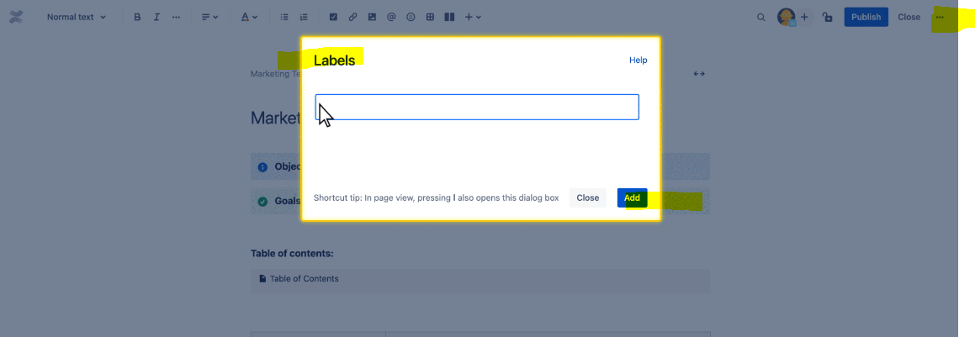Add labels to your pages to make them easier to find in search.

**4. Stay organized with parent and child pages**

**As you create more pages, you may find your space getting cluttered.**To reduce clutter, you can use parent and child pages to create an organized system. Parent pages set the high-level category. Child pages sit within each category.

For example, a sales team can create a new parent page called *Spring Summer 2022.*Their child pages fit within the category: *Sales meeting prep*, *Key product guide,*and *Revenue planning.*

Note that *any* page can be a parent page. It can be an existing page with content or a new page specifically created only to be a parent.

**Expert tip:**In the content of your parent page, try adding clickable links to the child pages. That way, readers that land on the parent page can easily find their way to the relevant child page.

**👇***Here's an example of an organized system with parent and child pages.*

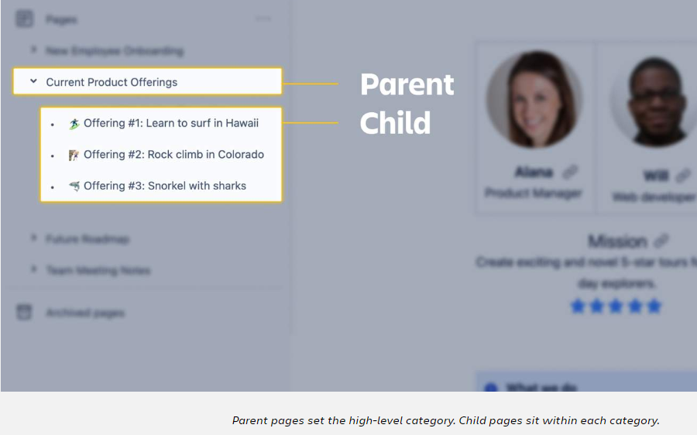

**5. Use keyboard shortcuts for quicker navigation**

There's a keyboard shortcut for nearly every action in Confluence: finding pages, editing pages, commenting on work, everything!

Within Confluence, you can access the complete list of keyboard shortcuts. There are three ways to access this list:

* **Use the keyboard command:**When viewing a page, press **shift**and **?**together
* **Use the main navigation bar:**At the top right of your screen, select the**?**icon, then ***Keyboard shortcuts***
* **Scroll to the bottom of any page:**In edit mode, scroll to the bottom and select the **?** icon

**👇***Here's a quick guide to some of the most popular keyboard shortcuts in Confluence.*

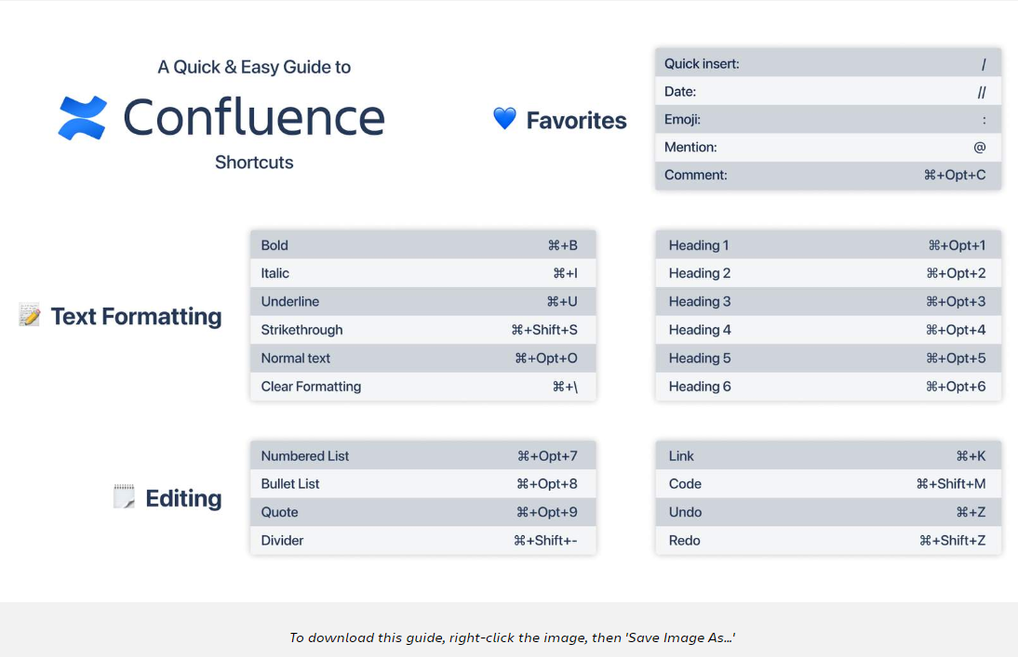

**6. Archive pages you aren't using**

**Keep your space tidy by archiving outdated or irrelevant pages.**Archiving a page removes it from your space and stores it away from your daily work. The page will no longer be available in the page tree or search.

Here's how to archive a page:

* View the page you'd like to archive and select ***More actions (•••)***
* Click ***Archive***

Archiving a page doesn't mean it's gone forever, don't worry! You can access any archived page at the bottom of the page tree by selecting ***Archived pages***.

**👇***Here's how to archive a page.*

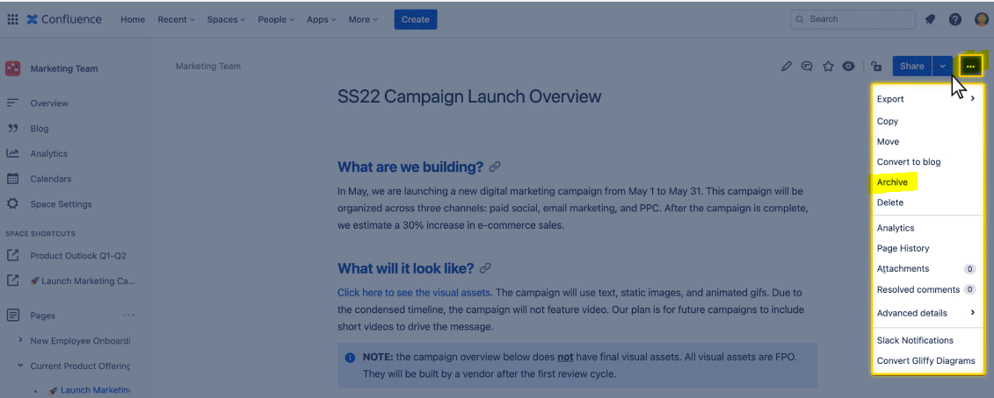Keep your space tidy by archiving outdated or irrelevant pages.

**Confluence gives you a place to share ideas, discuss challenges, solve problems, and express yourself.**It helps you unlock your team's full potential and accomplish more work together.

Let's dig into the best practices for **collaborating** in Confluence.

**Tips to collaborate in Confluence**

**1. Use comments for every conversation**

**Instead of chat and email, move every conversation to the Confluence comments.**This will boost trust and transparency across your team. And keep everyone's work in one place. You can start by @mentioning teammates to bring them into the conversation.

Remember, there are two types of comments you can use in Confluence:

* **Page comments:**Allow teammates to share general feedback about the page. Scroll to the bottom of any page to add a page comment.
* **Inline comments**. Allows teammates to collaborate on in-progress work, share feedback, and ask questions. Highlight any text on the page and click the comment icon.

**💥 If there's one best practice to take away from this lesson, it's to use the Confluence comments. For every conversation!**

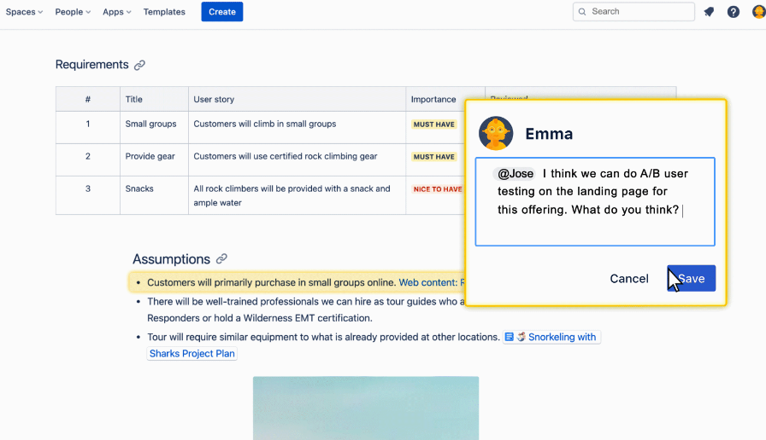Inline comments are used to collaborate on in-progress work, share feedback, and ask questions.

**2. Stay connected with email notifications**

**By default, Confluence sends a lot of emails. But they're all important!**You'll receive an email when any page you own, star, or watch gets updated. Or if you are @mentioned in a comment or page. Every email from Confluence includes a direct link so you can quickly navigate to the page.

📥 While all the emails may feel like overload, they are essential to help you stay on top of your work. You can change your email settings (as you'll learn soon), but we recommend you keep most emails on. It'll help you stay productive and in the loop on your work.

**3. Publish pages without notifying watchers**

Did you know that every time you click the*'Publish'*button, you might be email-spamming your team? Publishing a page this way sends an email to everyone watching the page. Even if all you do is make a minor update to a typo, everyone watching the page will get an email about it.

There's a solution for this. You can publish pages *without* notifying watchers. To do so:

* In edit mode, select ***More actions (•••)***
* Click ***Publish without notifying watchers***

This publishes the page the same way the*'Publish'*button does. The only difference is that Confluence won't send emails to your team.

If you edit and publish pages often, make this your default method for publishing any page. It's a helpful way to reduce clutter in your teammate's inboxes.

👇 *Here's how to publish a page without notifying watchers.*

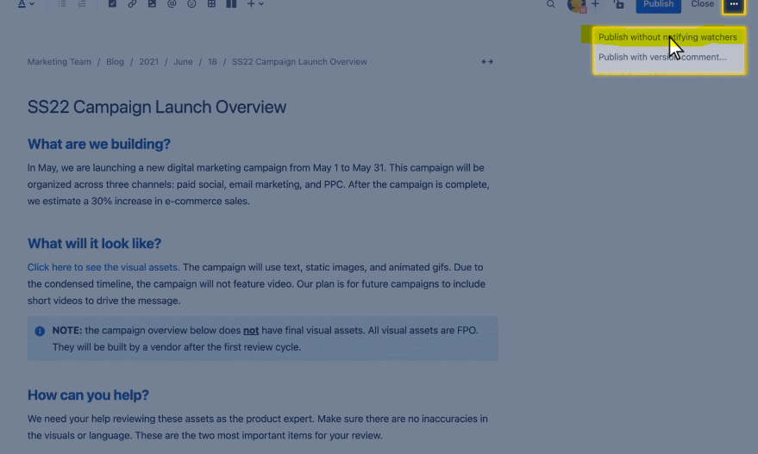If you edit and publish pages often, try using 'Publish without notifying watchers'

**4. Share editing links to collaborate in real-time**

**Remember, you and your teammates can edit a page at the same time with collaborative editing.** It's similar to any online document editor that includes live editing and real-time collaboration.

One easy way to invite teammates to collaborate in real-time is to share the page URL. Make sure you're in edit mode, then copy and paste the URL from your browser. Your teammate can click the link and begin editing the page with you.

👇 *Here's how to copy and paste the editing link.*

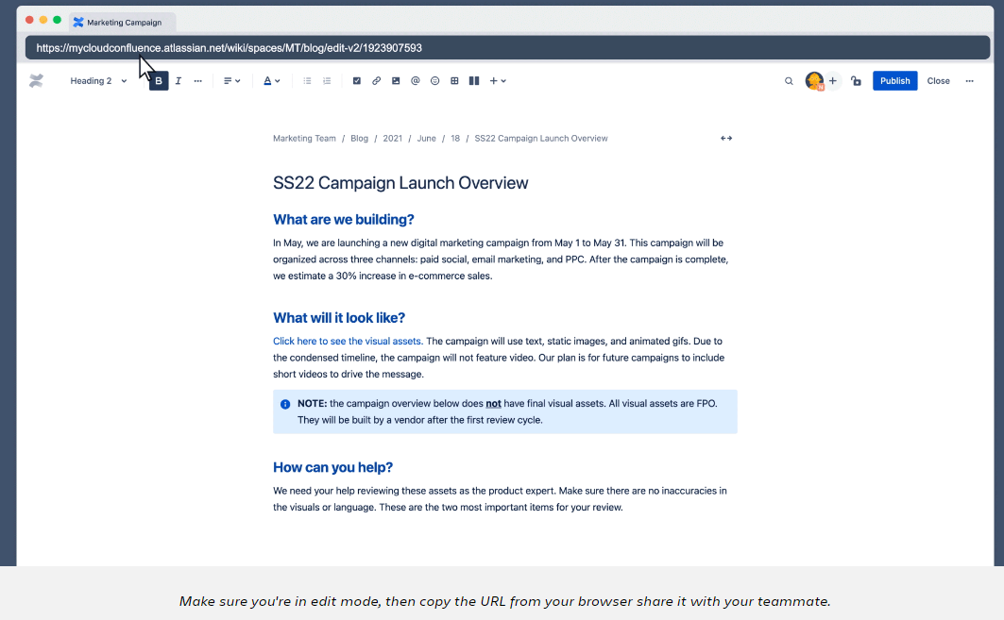

**5. Export pages for people outside your organization**

**You can export any Confluence page to Microsoft Word or PDF.** This is helpful if you're working with vendors or consultants outside your organization. To export a page:

* On any published page, select ***More actions (•••)***
* Hover over ***Export*** and click ***Export to Word*** or***Export to PDF***

If exporting to Word, the Word document will download automatically once clicked. The PDF may take a moment to process and require you to select***Download PDF***.

**👇***Here's how to export a Confluence page to PDF.*

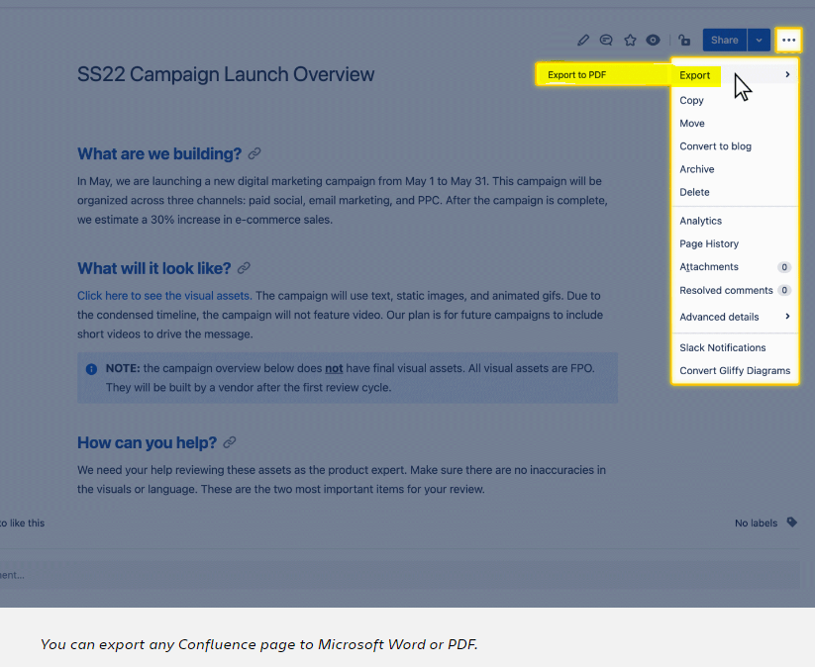**6. Control page permissions**

**Remember, you have complete control over who can view your pages.**Sometimes you'll need your entire organization to view your page. Other times you'll want to keep a page private, just for your own viewing.

Confluence is built for transparency. By default, your page will be set to *'Anyone can view and edit.'* Here's how to change the page permissions:

* Click the **lock icon** near the top right
* Use the dropdown to update page permissions, then select ***Apply***

If you want to create a page only you can see, change the permissions to *'Only specific people can view or edit.'*

👇 *Here's how to change the page permissions.*

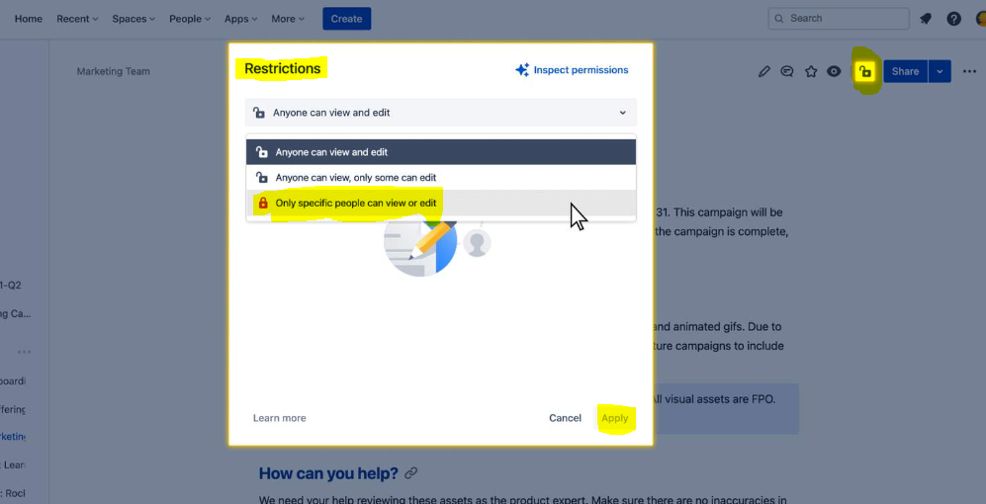To change page permissions, click the lock icon and use the dropdown to update

Confluence is a flexible tool, allowing for a variety of customizations. While your Jira admin or team leader will set up many customizations, there are a few important settings you can control.

To access your personal info, select your **profile picture icon** at the top right. This will populate a menu of options.

👇 *Click the numbers to learn more about each setting option.*

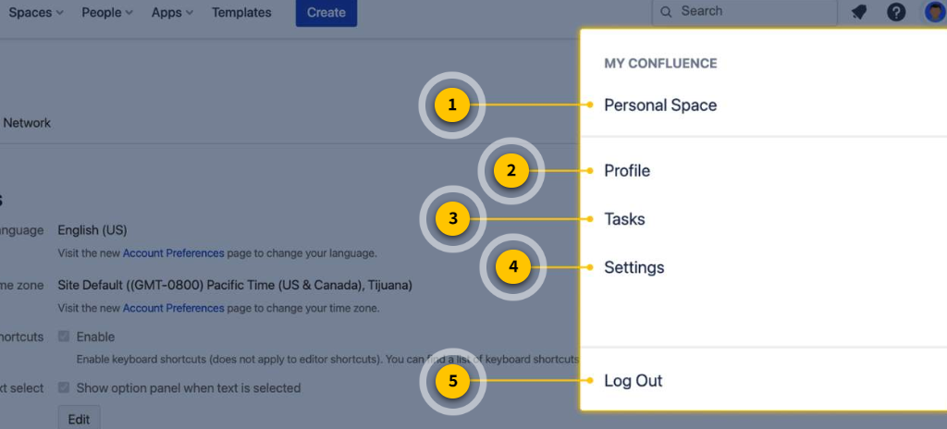**1. Personal space**  
Your **personal space** is a place where you can create your own pages and publish your own blog posts.

**2. Profile**  
Your **user profile** contains basic information about you, which other Confluence users can see.

**3. Tasks**  
Shows a list of the **tasks** you've been assigned in Confluence.

**4. Settings**  
Customize all your**personal settings** to make Confluence work best for you.

**5. Log out**  
A way to**log out**of Confluence if needed. The best practice is to keep Confluence open on your browser so it's easy to access.

**Tips to optimize your personal settings**

**1. Update your profile**

Your user profile brings clarity to your role, responsibilities, and personal interests. It helps your teammates get to know you and understand what you do. You can add a profile picture, your job title, and any other personal information you'd like to share.

Here's how to update your profile:

* Click your **profile picture** at the top right of your screen
* Select ***Profile*** from the menu

👇 *Here's how to create your user profile.*

**2. Personalize your email preferences**

As you learned earlier, email is a great way to stay on top of your work. In your personal settings, you can change the volume of emails you receive from Confluence.

If you prefer to receive fewer emails, uncheck the boxes for activities you're not interested in. You can always come back to your settings and update preferences as you wish.

Here's how to update your email settings:

* Click your **profile picture** at the top right
* Click ***Settings***
* Click ***Email*** in the far left panel
* Then, click***Edit*** and use the checkboxes to update your preferences

**Our recommendation is to keep your email settings as all-inclusive as you can manage.**This will help you stay on top of your work. If emails become unwieldy, you can try setting up an email filter (as you'll learn soon).

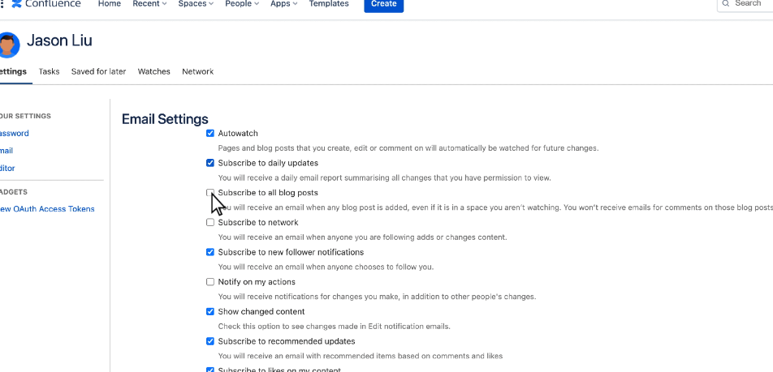**3. See all your Confluence tasks in one place**

Did you know you can assign tasks in Confluence using the action items macro? These tasks can help you track and manage your work. If your team is using tasks in Confluence, you can see them all in one place using the personal settings menu. Here's how:

* Click your **profile picture** at the top right
* Select ***Tasks***

Here you can toggle between tasks assigned to you and created by you. You can also see incomplete tasks and completed tasks.

👇 *Here's how to see all your tasks.*

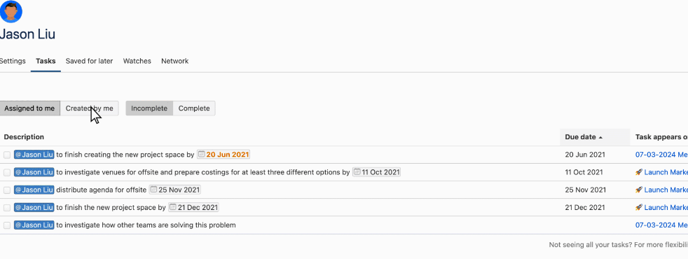

**4. Stop watching certain spaces and pages**

One way to de-clutter your inbox is to stop watching spaces or pages you no longer interact with. When you stop watching a space or page, you'll no longer receive email notifications about them. You can stop watching multiple spaces and pages by using the settings menu. Here's how:

* Click your **profile picture** at the top right
* Click ***Settings***
* Click the ***Watches*** tab from the top menu
* Click ***Stop watching***next to any space or page

👇 *Here's how to stop watching certain spaces and pages.*

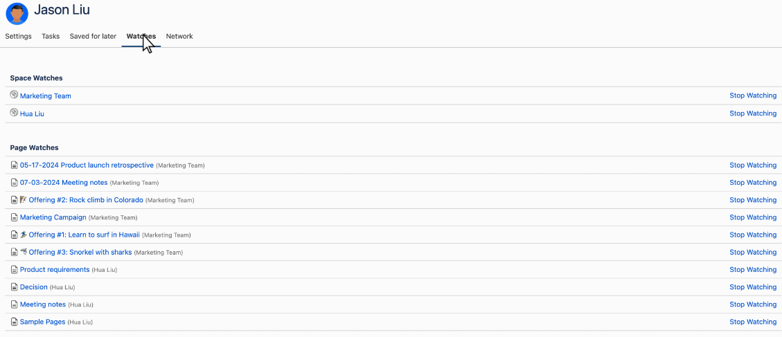**5. Manage Confluence emails with a custom email filter**

Okay, so this tip is going to take us on a brief detour outside of Confluence. But it's related to Confluence emails, and most pro users find it extremely helpful.

If you're receiving too many emails from Confluence, set up a filter using your email client. Many users find creating an email filter better for managing emails rather than changing their notification settings in Confluence. With a filter, you still get the important emails. But now, they're labeled, categorized, and not cluttering your inbox.

To set up an email filter, you'll need to do some light research to understand your email client. Know that the sender's email will always be [*confluence@<yourinstance>.atlassian.net*](mailto:jira@%3Cyourinstance%3E.atlassian.net)

## **Your Responses**

### **Question 1 of 30**

You want to make sure you stay informed about changes made to a particular page.  
  
Identify the correct action. 8904261

+1

* + Add the page to your starred items.
  + Share the page with yourself.
  + Watch the page.
  + Update your email settings.

### **Question 2 of 30**

Jules created a page to capture project ideas, but she does not want the entire team to view it yet.  
  
What should Jules do? 8904261

+1

* + Uncheck the box “Anyone can view and edit”.
  + Restrict the page to “Anyone can view, only some can edit”.
  + Restrict the page to “Only specific people can view or edit”.
  + Select the option “Publish without notifying watchers”.

### **Question 3 of 30**

Wanda began working on a brand new page.  
  
She needs to exit Confluence and wants to preserve her work, but she is not yet ready to share it with her team.  
  
What should Wanda do? 8904261

+1

* + Click the Save button in the main navigation bar.
  + Publish the page titled as “Draft”.
  + Schedule a publish date in the future.
  + Close the page.

### **Question 4 of 30**

A marketing team created various pieces of content including:  
  
1. marketing campaign roadmap  
2. new hire updates  
3. agenda for next monthly meeting  
  
What is the Confluence term for these pieces of content? 8904261

+1

* + issues
  + pages
  + spaces
  + templates
  + macros

### **Question 5 of 30**

Which two statements are true about Confluence pages? (Choose two.) 8904261

+1

* + Pages can contain rich, dynamic content.
  + All pages must be built using templates.
  + Every Confluence page lives online.
  + Anyone can create a page in Confluence.

### **Question 6 of 30**

Currently, your company stores various collections of related information in a file management system. Examples include:  
  
1. department-related resources  
2. company policies  
3. product support knowledge bases  
  
What is the term for these collections of related information in Confluence? 8904261

+1

* + tabs
  + templates
  + spaces
  + boards
  + page trees

### **Question 7 of 30**

Your Confluence site has several spaces with the following titles:  
  
1. NEMO product launch  
2. Q4 Holiday Party  
3. Platinum Care Marketing Campaign  
  
Which type of spaces are these most likely to be? 8904261

+1

* + team spaces
  + documentation spaces
  + knowledge base spaces
  + project spaces
  + personal spaces

### **Question 8 of 30**

Ainsley often needs to reference several Confluence pages that are located in different spaces.  
  
What feature will help him find the pages easily in the future? 8904261

+0 / 1

* + Drag them to space shortcuts.
  + Reorder them in the page tree.
  + Watch the pages.
  + Share the pages.
  + Star the pages.

The correct answer was "Star the pages.".

A. Incorrect. You cannot drag pages to space shortcuts. The pages are in different spaces, so there is no central shortcut location. And only space admins can create shortcuts. This would also affect the view for others. B. Incorrect. Since the pages are in different spaces, he would need to reorder multiple page trees and this would affect the view for others. C. Incorrect. Watching the pages will ensure he receives notifications about page updates and comments. It won’t help him find the pages. D. Incorrect. Sharing the pages will notify other colleagues. It won’t help him find the pages. E. Correct. Ainsley can add the pages to his starred pages for easy access later through the homepage or the Recent header in the main navigation bar.

### **Question 9 of 30**

Your company is using Confluence along with other Atlassian tools.  
  
Which location allows you to see and access this list of tools? 8904261

+1

* + feed on the Confluence home page
  + apps dropdown in main navigation bar
  + product switcher in main navigation bar
  + shortcuts on the space sidebar

### **Question 10 of 30**

Tomás wants to create a new page in Confluence using the main navigation bar.  
  
What should he click? 8904261

+1

* + People header
  + Recent header
  + Create button
  + Profile icon

### **Question 11 of 30**

Jose needs to locate two pages he was working on earlier in the day.  
  
He cannot remember the content but he knows they were in two different spaces.  
  
Identify two ways he can quickly locate these pages. (Choose two.) 8904261

+0 / 1

* + page tree
  + homepage
  + search bar
  + spaces dropdown
  + recent dropdown

The correct answer was "homepage, recent dropdown".

A. Incorrect. The page tree will only show pages for the current space being viewed. Jose needs pages from multiple spaces. B. Correct. The homepage includes a tab showing Recent work across multiple spaces. If Jose had been working on these pages earlier in the day, they would show up here. C. Incorrect. Since Jose doesn’t remember too much about the pages, he has other options that can help him locate them quickly. D. Incorrect. The Spaces dropdown allows Jose to navigate between different spaces, but it would not be the quickest action to help him locate pages within those spaces. E. Correct. The Recent dropdown shows Jose’s recent work, including pages he has worked on across multiple spaces.

### **Question 12 of 30**

You would like to create a page divided into three columns of equal size.  
  
What is the name of the Confluence macro used for this purpose? 8904261

+1

* + Layouts
  + Info panel
  + Headings
  + Frames
  + Divider

### **Question 13 of 30**

You are working on a page that is very long and difficult for viewers to navigate.  
  
You need a way to organize the content so that viewers can easily see the various sections on top of the page and click to jump to the sections within the page.  
  
Identify the correct macro to use. 8904261

+1

* + Info panel
  + Table of contents
  + Divider
  + Expand
  + Layouts
  + Children display

### **Question 14 of 30**

A few months ago, your coworker used a Confluence template to create a page, “Q1 Team Event,” to plan a team-bonding activity.  
  
You have just been asked to plan the Q2 team event.  
  
Identify the two quickest methods to get started on this in Confluence. (Choose two.) 8904261

+1

* + Create a Q2 page and copy the macros from the Q1 page.
  + Create a Q2 page using the same template as the Q1 page.
  + Copy the Q1 page and edit the copy to become the Q2 page.
  + Archive the Q1 page, then copy as a Q2 page.
  + Clone the Q1 page into the Q2 space.

### **Question 15 of 30**

Review examples of content created in Confluence:  
  
1. “Advisory Meeting Minutes 05-23-21”  
2. “Project Notes 06-01-21”  
3. “Project Nemo Q1 Roadmap”  
4. “Hello, I’m Arun; your new summer intern”  
5. “Reflections from my sabbatical”  
  
What are the correct terms for these content types in Confluence? 8904261

+1

* + pages and notes
  + blog posts and notes
  + pages and blog posts
  + documents and files
  + templates and notes

### **Question 16 of 30**

Karla has been editing a published page but wants to discard her changes.  
  
Identify the Confluence feature Karla can use. 8904261

+1

* + Revert to the last published version
  + Preview the page
  + Undo recent changes
  + Publish with version comment
  + Restore this version

### **Question 17 of 30**

Abby authored several pages in your team space.  
  
She set restrictions on one of the pages and you are not listed as a viewer.  
  
Which statement is true about this page? 8904261

+0 / 1

* + Someone else can still share it with you.
  + You can see it in the page tree but not open it.
  + You can see it in search results.
  + Its child pages will also be hidden from you.

The correct answer was "Its child pages will also be hidden from you.".

A. Incorrect. You need to be listed as a viewer in order for another viewer to share the page with you. B. Incorrect. If you cannot view a page, you will not see it in the page tree. C. Incorrect. Since you are not a viewer on the page, you cannot search and find it within Confluence. D. Correct. Confluence has inherited view restrictions. If you cannot see a parent page, you also cannot see its children.

### **Question 18 of 30**

Which statement about Confluence access is true? 8904261

+1

* + Page permissions can be limited to roles.
  + Personal spaces are always hidden to everyone but the author.
  + Hiding a parent page will automatically hide the children.
  + Archiving a page resets the page permissions.

### **Question 19 of 30**

You need to locate a particular page in Confluence.  
  
You know several keywords that definitely appear on the page, including infrastructure, monetization, and transformation.  
  
What is the best way to search for this page to get the fewest, most accurate results? 8904261

+0 / 1

* + Search with keyword shortcuts.
  + Search with an exact match.
  + Search with operators.
  + Search with wildcards.

The correct answer was "Search with operators.".

A. Incorrect. Searching with keywords will likely return too many unrelated results, depending on how often those keywords appear on other pages. This is not the best way to get the fewest, most accurate results. B. Incorrect. Since you only know a few keywords, you would not want to search for an exact match within Confluence. C. Correct. Searching using operators, like OR, AND, NOT, or a Group search can help you get more defined results. In this situation, since you know that all three keywords are on the page, you can use an operator to focus on results that contain all keywords, as opposed to results that may also include only one or two of the keywords. D. Incorrect. Since you know full keywords, you would not need a wildcard search, which allows you to replace characters within a search. Using wildcards will likely return too many unrelated results.

### **Question 20 of 30**

Yesterday, you created a page titled “Game Night on July 2, 2021”.  
  
Today, your coworker Anne created a page titled: “2021 Team Event Planning”.  
  
What should you do to help keep Confluence well-organized? 8904261

+0 / 1

* + Reorder her page underneath your page.
  + Copy your page and move it under her page.
  + Archive your page into her page.
  + Drag your page to her page in the page tree.

The correct answer was "Drag your page to her page in the page tree.".

A. Incorrect. Your page should be underneath Anne’s. B. Incorrect. You only need to move the page. You do not need to copy it. C. Incorrect. Since you’ve just created the page, you do not need to archive it. Also, you cannot archive into a page. Archived pages are stored in a separate section. D. Correct. Based on the titles of the pages, Anne’s page (2021 Team Event Planning) is a logical parent of your page (Game Night on July 2, 2021). Your page should be dragged underneath hers in the page tree.

### **Question 21 of 30**

Identify one way that Confluence users can reference a list of keyboard shortcuts. 8904261

+1

* + Click the shortcuts icon while viewing a page.
  + Type “/ k” while viewing a page.
  + Click the help icon (?) from the main navigation bar.
  + Type “shortcuts” into the search bar.

### **Question 22 of 30**

Sofie created several pages in the Human Resources space, all of which are related to Onboarding.  
  
She wants new hires to be able to locate them easily in the future.  
  
Which two actions will meet this need? (Choose two.) 8904261

+1

* + Use unique, consistent labels.
  + Organize all child pages underneath a parent page.
  + Export the pages to a separate space.
  + Use share and mentions.
  + Star the pages.

### **Question 23 of 30**

Cindy is confused about some content located halfway through a page she is reviewing.  
  
What is the easiest and clearest way she can point the author to the location of this content? 8904261

+1

* + Add a page comment.
  + Create an anchor and copy the link to share.
  + Add an inline comment.
  + Select the content and star it.

### **Question 24 of 30**

Several people have been asked to review Bob’s marketing plan.  
  
You have concerns regarding the overall tone and style used throughout the page.  
  
You want to provide feedback that all viewers can see.  
  
Which feature should you use for this purpose? 8904261

+1

* + Page comment
  + Page task
  + Inline comment
  + Share with message
  + Collaborative editing

### **Question 25 of 30**

You need to share several Confluence pages with an external vendor, ACME.  
  
ACME employees are not Confluence users. They do not, and should not, have access to your Confluence site.  
  
Identify the correct way to share the pages. 8904261

+1

* + Use page export.
  + Add the domain to space settings.
  + Share using individual email addresses.
  + Use @ mentions on the pages.
  + Email individual page links.

### **Question 26 of 30**

Which feature does NOT help maximize team collaboration in Confluence? 8904261

+0 / 1

* + Collaborative editing
  + Comments
  + Mentions
  + Page restrictions
  + Sharing pages

The correct answer was "Page restrictions".

A. Incorrect. Collaborative editing allows teams to work together simultaneously (up to 12 people at a time) on one page. B. Incorrect. Adding comments to pages allows teams to work together better on reviews and edits in shared spaces. C. Incorrect. Mentions help draw your team’s attention to particular content and hence collaborate better together. D. Correct. Page restrictions limit who can see – and therefore collaborate on – certain pages. While page restrictions are a useful Confluence feature, they do help maximize team collaboration. E. Incorrect. Sharing pages is a great feature to encourage collaboration by allowing pages to be shared with other team members or stakeholders.

### **Question 27 of 30**

Tony wants to limit the notifications he receives as a result of changes to some pages.  
  
Identify one Confluence feature that Tony can use. 8904261

+1

* + Unwatch the pages.
  + Remove the pages from his starred items.
  + Remove the pages from his recent list.
  + Create custom email filters.

### **Question 28 of 30**

You receive too many email notifications from Confluence.  
  
You prefer not to receive an email each time someone likes the pages you have created.  
  
How can you fix this problem? 8904261

+1

* + Remove yourself as a collaborator on the pages.
  + Update your email notifications in personal settings.
  + Remove the pages from your starred items.
  + Disable the like function on your pages.

### **Question 29 of 30**

Ann is updating pages created by others.  
  
She needs to limit the notifications others receive as a result of her changes.  
  
What should Ann do? 8904261

+1

* + Remove page watchers before publishing.
  + Use page restrictions.
  + Remove them as Collaborators.
  + Publish without notifying watchers.

### **Question 30 of 30**

Your manager instructed that all newly-created pages related to release notes in your space must have the same standardized look and feel.  
  
This includes text styles, macros, and layouts.  
  
Which solution helps meet this requirement? 8904261

+1

* + Build a page from a space template.
  + Create a custom page template.
  + Save a page as a template and star it.
  + Add custom page labels.
  + Create a page from a Google Doc import.